Description
A Teacher Work Sample (TWS) is designed to assess the impact of teacher candidates’ instruction on students’ learning as well as provide evidence of candidates’ teaching performance during the Student Teaching Experience. The TWS assignment includes the following components:
- Contextual Information and Learning Environment
- Individual Student Information (Case Study)
- Management and Motivation
- Instructional Design and Implementation (Unit) V. Analysis of Student Learning (Unit)
VI. Reflection and Self-Evaluation (Goals)

Format
Ownership: Complete the cover page verifying the TWS to be your own authentic work.
References and Credits: If you refer to another person’s ideas or material (such as theorists), cite these in a separate section at the end of the TWS under References and Credits. (APA is recommended)
Font and Spacing: Use Arial size 12 font, double space all narrative portions, and print on both sides.
Anonymity: Do not include the names of individual students, teachers, or staff as well as participating schools in any part of the work sample in order to insure the anonymity of all involved.
An electronic copy of your completed TWS must be submitted to:

- Your university supervisor (discuss the format)
- D2L for Student Teaching (488) course
- Your electronic portfolio/professional website (please remember to remove the cover page with identifying information before posting).

I. Contextual Information and Learning Environment (due week 2)

Task: Candidates gather contextual information and discuss factors that may influence the teaching and learning process.
No specific titles/names or means of identification should be used.

Resources: Use a variety of resources to gather contextual information including the School Improvement Plan, cooperating teacher, Title I/SPED teachers, principal, school counselor, Infinite Campus, student files (with administrative approval), school data available online. http://doe.sd.gov/reportcard/listnew/

Contextual Information Data
Student Teaching Experience

Using this form, gather and record the information needed to write the narrative portion of your Contextual Information section of your TWS. Please be aware that additional information is required for this section (see instructions on TWS)
6th Grade Level
HS 182
MS 132 Total school enrollment 7 Females in classroom
21 Total classroom enrollment 14 Males in classroom
yes Free or reduced lunch participant at school (yes or no)
n/a Instructional aides/para-professionals in cooperating classroom
Ethnicity of Students:
1 African American/Black Native Hawaiian/Pacific Islander
1 American Indian/Alaskan Native 17 White
1 Asian 1 Two or more races
Hispanic/Latino Unknown ethnicity
Language Proficiency of students
Fluent English Proficient English Language Learner
Identified Special Needs (IDEA Categories)
Autism Orthopedic Impairment
Deaf-Blindness 1 Other Health Impairment
Deafness Specific Learning Disability
Emotional Disturbance Speech or Language Impairment
Hearing Impairment Traumatic Brain Injury
Intellectual/Cognitive Disability Visual Impairment
Multiple Disabilities

Classroom Setting
This art classroom is made up of six tables that seat four students at each table. The tables are studio styled tables that have a stool at each. There are eight different periods of students that come in and out of this room each day. The classroom usually has a smaller amount of students never completely filling each table. The largest of those classes would be the 6th grade class of 21 students. The tables are spaced out evenly across the entire room.

Contextual information continued

School X resides in a small town with a population of 1600 people and is 20 miles from a larger town. The population density is about 830 inhabitants per square mile and there are an average of 630 housing units. The racial makeup of the city is 97.5% white, 0.3% African American, 0.5% Native American, 0.1% Asian, 0.2% from other races, and 1.4% from two or more races. The gender makeup of the city is 49.3% male and 50.7% female. School X is the only middle/high school in the small town and there is one elementary school as well. The total school enrollment of middle/high schoolers is 314 students.
School X is broken up into the different wings of classes. The art classroom resides on the second floor of the building with a great ventilation system, and four large windows that allow a great amount of natural light in. Some classrooms have Promethean Boards, although the art classroom does not. The art classroom has a projector and projector screen. Students in their sophomore year are given a laptop computer, which they are in charge of until they graduate as seniors. Middle school students and freshman are able to check out computers temporarily from the library.
In the 6th grade art classroom there are 21 students, 14 boys and 7 girls. There is only one student who is on a behavioral IEP. This is the first art experience these student have had in junior high, and they are to complete one quarter of art, which is about 9 weeks. They cover things like ceramics, hieroglyphics, and colored pencil values. They are required to take art or music up until high school where they are then supposed to have one credit in art. Majority of the 6th graders in art seem to enjoy the projects that they are completing. They are starting to find out the things that they are excelling at or the things that they may not like as much.

Instructional Implications- What implications do the contextual factors related to the community, classroom and student characteristics have for planning instruction and assessment? Include specific instructional considerations that will influence how you plan and teach your lesson(s).

The physical layout of the classroom currently consists of the students sitting at six tall evenly spaced out workshop tables, with four stools at each table. When creating a seating chart, I will strategically place students who I know talk a lot more, at the front of the classroom, next to the teachers’ desk. When students gain the privileges to move, I will allow them to then choose where they would like to sit. These strategies not only provide students with the opportunity to succeed by not talking and listening better, they are also given an incentive to do their work and have good behavior, so they are able to move to where they want to sit. There is currently one student who is on a behavior IEP, who does not leave the classroom during his art hour. Therefore, I will be sure to pay close attention to him and find ways to keep him working hands on and stay motivated in my classroom.
I thoroughly enjoy the layout of the room and how the students are seated at tall work tables. In my own art classroom, if it is an option, I will choose to have high work tables for my students. It is beneficial for students who enjoy standing while they work, as well as for students with a behavioral disorder who prefer to stand and be active. The high tables allow them to move around and get to every part of their artwork.
Being this room consists of 6th grade middle schoolers who are still learning and developing their skills in art, the projects they do are content based that follow the art standards. Having basic content assessments for these students sets them up for what is to come as they continue through art. They are learning the basics that they will be able to take with them through junior high and high school art classes. This class utilizes and encourages hands on learning and allows each and every one of these students to learn individually, but are still able to ask for help from their teacher. I will need to teach to each of the student’s abilities. I will keep in mind as I plan my lessons the type of students I have in the classroom and not forget the student I have that is on a behavior IEP. I will keep all the lessons hands on, allowing for students creativity and individuality.
One of the main implications for the students in my class will be making sure that I work at a pace that is reasonable for them. In my art classroom it is more beneficial to allow students more time to work on projects. The more time they have, the more successful they are with their art. As well as the better outcome of art projects there are. There are multiple students in the art classroom who are highly talented in art and succeed greatly in every project they do. In my own classroom I will be sure to keep all students engaged and motivated in art by letting them be creative and unique on their own. Allowing students the room for creativity gives them the chance to have great potential in art.
Another factor that I will keep in mind as I plan my lesson, is the type of assessments I will give these students being they are 6th grade students who are taking art for the first time in junior high and are learning the fundamentals and basics of art methods. I want to keep them interested and engaged in the lesson I will be teaching. I need to be aware of how much assistance I will provide the students equally. It will important to focus on the strengths of each student and how well they are learning the concepts of art. As I set up my lesson, it will be important to allow enough time, practice and assistance as the students complete the given material. All of these factors I will be sure to keep in mind when I have my own classroom.

II. Individual Student Information- Case Study (due week 6) Task: Candidates demonstrate understanding of how individual student’s physical, social, and emotional development impacts his/her learning. Candidates are able to identify research-based strategies to assist and support student learning.
*K-12 placements may choose level at which the case study is completed.
- Select a student from your assigned classroom.
- Observe the student and record your observations.
- Consult with the cooperating teacher to gain information about the age, developmental level, socio-economic status, family make up, school performance/grades, special needs, etc. Be sure to gain administrative approval to view student records or cumulative file.
- Through observation, assess and analyze the way your selected student learns and performs.
- Based on your assessment of this student’s learning or behavior, research ways to effectively adjust instruction to help the student reach his/her full potential.
- Using the data collected and current research, write a paragraph for each of the following:
  - Justification for why this student was chosen for the case study
  - Description of background information and observation on the student. Do not use the names of the student, teacher(s), or school.
  - Identification of the main issues
  - Analysis of the issues and how the student’s learning and performance in the classroom are affected
  - Reflection on effective solutions and strategies to help the student reach his/her full potential
  - Cite references

Haley Rheault
Case Study

The percentage of children projected to have ADHD has greatly increased over the last ten years. Roughly 11% of children ages 4-17 are diagnosed with ADHD. What is ADHD? Attention deficit hyperactivity disorder, a chronic condition that is marked by persistent inattention, hyperactivity, and sometimes impulsivity. In other words, a disorder in which someone is unable to control their behavior. ADHD begins in childhood and can often last into adulthood. As many as 2 out of every 3 children with ADHD will withstand symptoms as adults.
Attention deficit hyperactivity disorder has been proven to be more common in boys, at 13.2% and less likely in girls at 5.6%. The number of children taking ADHD medication has also increased greatly, although, the number of children currently without ADHD treatment is much larger. Although there may be numerous effects with undiagnosed or untreated ADHD, there may also be side-effects with taking ADHD medication.
Yes, ADHD medication may allow that child to be more focused and perform better with daily life activities, but it could also affect them physically. Things like having trouble sleeping, decreased appetite, delayed growth, and even moodiness and irritability can all be factors that affect a person from ADHD medication. Common ADHD medications include, Ritalin and Concerta. Symptoms can vary depending on which medication is prescribed. With that being said, it is important to keep in mind that there may be natural ways we can help a person with ADHD.
It seems that now days it is always easiest for someone to label a child with such disorder. But, until a child is officially diagnosed with attention deficit hyperactivity disorder, there should be no problem with accommodating classrooms to provide activity for all students. For this reason the student I have chosen to complete my case study, is student A.
Student A is an 11 year old in the 6th grade who has been diagnosed with attention deficit hyperactivity disorder. Student A was diagnosed in first grade has been on and off ADHD medication. Student A has had the most trouble in school and that is when it was brought up about being placed on an ADHD medication. Student A became very disruptive and class and was distracting to other students. Student A was unable to stay focused in school due to the constant need to be moving and messing with something.
As soon as student A was placed on medication he began to show improvement in school and in class. He was less distracting and could stay focused a lot longer, thus, showing improvement with his grades. After being on his medication for some time his mom noticed that it was causing a stunt in his growth and a loss in his appetite. Student A’s mother decided to take him off medication completely and seek other accommodations for her son.
If you were to see student A in the hallway or in class, there is a noticeable difference in his height and weight. He is much smaller in height and weight, compared to other students in his grade. The stunt in his growth has been an issue, I believe, since shortly after placing him on the medication. I am unsure, because of the lack of access to medical records, the medications that he has tried or been placed on. But, because of the stunt in his growth, his mother had taken him off of the ADHD medication he was on. While he was off medication his grades were decreasing noticeably and his behavior seemed to decline as well. His ability to focus on things for a long period of time became less and less.
Things were getting to the point where they were as bad as they were the first time around, so it was recommended that he see his doctor and figure out something to do so he is able to better stay focused in school. From what I know his mom agreed, because he now is back on his ADHD medication. I am not sure whether the medication is the same as before or if his doctor chose a medication different for this time around. All I know is that his grades have showed a sufficient increase in the last two months. After talking to his teachers I have gathered a few of his grades currently. He has the grade of an A, in art, a C in math, B in English, and a C in history. These grades show much improvement from what they were while he was off of his medication.
The ADHD medication has made a significant difference with his behavior at school. He is able to listen much better and stay focused better as well. While in class I have noticed that for the most part, he doesn’t say much, unless he is being asked a question or has a question. He stays quiet and works on his art for the entire class hour. He really enjoys art and being hands on and does very well with it, his work shows that he takes much time on it.
When student A is in class, not only are you able to pick him out compared to others because of his size, but his body language and actions are much different from other students as well. In the art classroom there are high tables with stools at each table, student A sits on the stool hunched over, very “pretzel” like, with his legs and arms all inter-twined. He sits and will pick at things on the chair, on the table, or even at his finger nails. He will also bite at his finger nails until they are down to barely anything.
Student A is very articulate and likes things a certain way. When working on art he likes to pick out fine details and get every last element of his art projects that he can. In other classes teachers say that he needs to always have something in his hands, or needs to be constantly working on something. They also have said that he likes to take things apart, such as mechanical pencils, and things like that. He struggles in classes where there is not much to be doing that is hands on. In art he does well and has no troubles with listening or staying focused. In classes other than art teachers give him a stress ball or a piece of clay that he is able to work with while he is listening. Doing this has helped him stay focused because he is able to keep something in his hands and is moving.
His mom and dad are separated and he spends majority of the time with his mom, especially during the school week. There will be an IEP meeting set in place with him, his parents, and his teachers. I will not be able to attend this meeting, due to the respect of privacy requested by his parents. Before the meeting will take place I went ahead and talked to the counselor to get a little more information on student A. There is reason to believe that student A may have the slightest degree of Autism. This is believed, due to some of his behaviors and actions we see during the school day.
If his parents would agree to it, student A would then go to a special education classroom for assistance in his regular classrooms. The extra assistance may be beneficial for student A, to support him with his daily assignments. With the lack of being able to focus student A may not always get the full amount of information that is needed to complete his assignments. But if he has a room that is quiet and provides the accommodations necessary for him to succeed, then I believe he will have more success in the classroom and with his grades.
With that, allowing student A something to hold on to or mold in the classroom is a good idea to keep him occupied. Like I said earlier, some teachers were allowing him a small ball of clay or even a stress ball that he is able to hold on to during class to keep him focused enough. With art it is easy to allow students the option to stand at their tables being they are tall enough and they are working hands on. In other classes it may be hard to incorporate students being hands on, so finding taller desks for students to be able to stand at, or even a ball to sit on to keep them from sitting completely still.
ADHD has a large effect on children in our society today and continues to grow in percentage through the years. It is important that we as teachers are able to make accommodations in our classroom to meet the needs of every student. Every subject has the room to make accommodations, it just takes a motivated teacher to meet those accommodations. With art, it is easy to meet the needs of all students because they are able to think freely and be creative on their own. Students are able to move openly throughout the classroom, getting supplies, and interacting with different media, as well as others within the classroom.
When I have my own classroom I will be sure to make accommodations to meet all students including those with behavioral disabilities. If it is in option, I will have higher standing work tables. This way students with ADHD are able to move around and stand if they choose to. There will be stools as well for students who do not choose to stand. I will have my students go and get their materials so they are able to move throughout the classroom, as well as let them work in partners to get the interaction with other students.
If my classroom was not an art classroom, where students were already hands on and moving around the room on a daily basis, I would make other accommodations. Those accommodations would include things like having standing desks at the back of the classroom, to allow students to stand when working. I would allow students to have play-dough or clay to hold in their hand when working, or even a stress ball to keep them moving in order to stay on task.

*Information was obtained from the school counselor, my cooperating teacher, the reading teacher, the math teacher, and the history teacher.

*Internet Sources for ADHD statistics:
“Attention-Deficit / Hyperactivity Disorder (ADHD)”, Centers for Disease Control and Prevention. 2016 http://www.cdc.gov/ncbddd/adhd/data.html

III. Management and Motivation (due week 4)
Task: Candidates use an understanding of individual and group motivation and behavior including effective verbal and nonverbal communication techniques to create a positive learning environment. Write a paragraph for each of the following:

- Description of classroom environmental factors you observed that affect learning.

The first thing that catches ones attention when entering the classroom would be the different style of workshop tables. The tables in the classroom were hand build by the shop teacher and have four chairs at each table, with 3 cubbies on each side for students to keep their folders. I thoroughly enjoy the tables and the layout of the room. I feel that the cubbies in each table is an excellent idea for students to keep their work. In my future classroom I hope that I will have the option to have high standing workshop tables as well.
On the south wall in the classroom there are large cupboards that hold all of the extra materials, such as paper, for the classroom. On the north side of the classroom there are two sinks and another set of large cabinets that store the paint and other media used in art. Students are supplied most of the media, but are required to buy their own canvases for painting and materials used for sculptures. I feel that the amount of storage for an art classroom is not very much, but how the supplies are organized and placed in the area provided, it is used very well. If I were given the amount of space that this particular art classroom has, I would organize the supplies in the same way that my cooperating teacher has.
At the front of the room, my cooperating teacher has her desk facing the wall, and then another desk in which she usually stores finished projects ready for grading. If this were my classroom I would rearrange my desk so that it would be, in some way, facing the students and not at as easy of an access for students to see everything on. There is one white board in the room and four different boards where my CT pins up news and different things for students’ knowledge. Covering the west side of the wall there are large windows that allow a great amount of natural light in, which is very beneficial for an art classroom. In the hallway outside of the classroom there are two full walls of area that you can hang the students’ art work. I really like the idea of being able to display students work for others to see. When walking down the hallway one is able to see that you are entering the art wing because of the full hallways of students’ work. All in all, everything in the classroom is being utilized and has a purpose of why it is there.
In the classroom, an environmental factor that I observed, that would have an effect on learning, would have to be the temperature in the room. As I have monitored the room I have noticed the temperature in the room is never consistent. Most of the time it is really warm in the room and my CT has to open the windows to cool it down. Having it too warm in the room can cause distress for these students during their learning. It also causes distractions from students getting up out of their seat to open the window or open the door for a breeze. During the winter the room can be very cold as well but my cooperating teacher normally chooses to do clay in the winter, so when using the kiln, the room heats up pretty quickly. Another factor with temperature that also affects students learning is the fact that there is no air conditioning in the classroom. That is why my cooperating teacher plans what media she uses and when. Like said above, my cooperating teacher will plan her two clay units in the winter months.
If this were my classroom and the temperature was very inconsistent I would ask the school board if it would be ok to get a window unit air conditioner. The unit would help in the warmer months to keep the classroom cool and at a reasonable temperature. As for in the winter if the temperatures were cold I would do like my CT has done, and run the kiln for firing to warm up the classroom.

Description of individual student motivation strategies used (e.g., giving choices)
The main individual student motivation strategy that I have seen in this specific classroom is how my CT allows for each of the students to have choices. At the beginning of the semester or term, my CT discusses with the class which topics they would like to choose for their sketchbooks. The students get in 5 groups and each group gets to choose one topic, which leaves 6 topics in which my CT allows students a “choice” of what they would like to draw in their sketchbooks. They turn their sketchbooks in every week and this allows students to practice their art skills, while drawing what they as a class chose or what they choose individually as their “choice” sketchbook.
I like this strategy of allowing students to “choose” for themselves. I would support this idea in my own classroom, and allow my students choice on what sketchbook assignments they would like to have assigned. I would also go over with the students a grading rubric and allow them to decide what specific things about their sketchbook should be graded on. This sets the students up for knowing what will be expected of them on every single sketchbook assignment they have.
Another individual student motivation strategy used is how my CT is always presenting new information with such excitement, which then causes the students to be interested in what they are learning about. Also she gets students actively involved in the learning process by allowing them to handle materials on their own. Being it is an art classroom there are a lot of hands on activities and it gives students the opportunities for their own creativity and individuality. Along with that my CT also promotes independence frequently in the classroom and encourages students to get supplies on their own. If they need something to finish an art project they are able to get it on their own being everything is labeled and organized.
I will also use these motivational strategies in my own classroom. Being excited when presenting students with new projects is a great way to get them motivated and ready to work. I plan to always show excitement in everything I teach, to keep my students on task and ready to learn. I will also allow my students to use the materials freely in my classroom. They will have access to all the materials they will need, and will be organized and labeled. If supplies start to become damaged or missing, a class discussion will be held to see what needs to be addressed when using materials.

- Description of group motivation strategies used (e.g., counting backwards, voice level barometer, silent signals).

In the 6th grade art classroom there are six tables that sit four students at each table. The students sit in their assigned spot to take attendance at the beginning of class and then are allowed to move to a different spot to sit by someone using the same materials they are. For example if they are glazing their clay pieces they can sit by someone using the same color of glaze that they are. This is a great way to get students moving and allowing them to help one another with ideas for their projects. Another group motivational strategy is that students sit in grouped tables and are able to see what other students are working on to get motivated about their own art work. For the most part, at each table there is one student who excels in art and the rest of the students at that table are able to see that and which gives them the motivation to try their best on their art work.
Allowing students to sit next to others and gain ideas from one another can be very beneficial and would be something that I plan to implement in my own classroom. Being with others motivated to work, will motivate individual students by observing each other’s work. In turn it can then allow them to excel in their own work.
It can also be something that isn’t beneficial due to students’ lack of creativity and possibility of them coping an idea. By grouping students together in an art classroom, you may face the chance of this happening, but overall the teacher is in charge and if they choose to copy someone else’s work then they may risk receiving a failing grade.
In my own classroom I will make the decision to allow my students to sit in groups based on their level of creativity that I see in the first couple weeks. At the beginning of the year I will make seating charts for students and once I know what each student is capable of, I will then make the decision of where and how they will be placed around the room.

- Describe verbal and non-verbal communication occurring in classroom interactions among students and with the teacher.

In the art classroom my CT uses some verbal communications but not as many as her non-verbal communications. Being this art classroom consists of middle schoolers she treats them as middle schoolers and not elementary. So to get the students attention she usually just says “ladies and gentlemen” when she walks in the room and to the students this is the cue for them to sit down and be quiet. For the students that don’t always listen and aren’t quiet she then uses non-verbal communication. Things like waiting and starring at the student, or she will stand with her finger in front of her mouth signaling that students should be quiet. I find this to be affective because students will then realize they can’t start and will tell that student who is not listening to be quiet.
Other techniques that my CT uses that I find useful are things like standing next to the student who is continuing to talk when they are not supposed to, or moving them to the front of the classroom next to the teachers desk so that student is then under close supervision throughout the class hour.
In my own classroom I will use a verbal cue such as “ladies and gentlemen” when entering the classroom to get their attention. For the students who I may struggle with to get their attention, I will use non-verbal communication signals, and if all else fails I will then seat them at the front of the classroom to keep a closer eye on them.

- Implement one management technique and reflect on its effectiveness.

While in this particular art classroom, the best way to manage the students in this class is to refer to them as ladies and gentlemen. When my cooperating teacher or I need the students’ attention, it is best to call them “ladies and gentlemen. The reason for this is that these students are middle and high school students and they are too old for any type of clapping or repeating. By speaking in a louder tone of voice and showing them respect by calling them “ladies and gentlemen,” they are more likely to have your attention and be motived to learn. To the students they know this as a signal to stop what they are doing and start listening.
The other management technique that I have incorporated into my lessons really gets the students listening and ready to learn before introducing a new media. The students are used to typically blurting out answers, so while having a discussion with students I would call on them individually and ask them questions. If they did not know the question they were then able to “phone a friend” at another table, who may know the answer. The students follow along better with this technique because they want to know the answer when they are called on.

- Include your School-Home Communication artifact.

The main type of communication that is used in my particular classroom is verbal communication. My cooperating teacher and myself instruct and present information to the students verbally during class. Our usual communication is our “teacher voices”, when we are demonstrating a media or introducing a media to the students. Another type of communication used is when we are working one-on-one with students, talking about their projects and assisting them when needed.
To make sure students stay on task, my cooperating teacher and myself walk around and make sure they are working on their projects, and to assist them with whatever it is they may need. Another type of communication that is used is hand gestures. With this we are able to let the students know what we expect without saying anything.
School-home communication consists of phone calls, a monthly newsletter, and parent-teacher conferences. In the newsletter the teachers tell what they will be working on in their classroom for that four weeks. Usually a phone call consists of parents/guardians needing to talk to teachers right away or vice versa. At conferences the students with a grade of a B or lower, their guardians are required to see the teachers of the class in which they receive those grades. So not always will the teacher see the families of each student.
In my classroom I would like to first of all send a letter home within the first two weeks of class. This is a good way to introduce myself to the families. In that letter I would request that the families of my students please attend conferences no matter what grade they receive so I am able to get to know them as well as communicate what I have noticed about their child thus far. I would also like to implement a blog for my classroom. With this blog I will talk about what projects we are doing and display student’s art work as well. This way families are able to see what is going on with their child in the art classroom.

Family Communication Letter

Dear Families,
Hello, my name is Ms. Haley Rheault. I am currently a senior at Northern State University where I am majoring in art education. I am originally from Fargo, North Dakota, but have lived in Aberdeen ever since I graduated from high school. I really enjoy being in South Dakota and have hopes of becoming an art teacher in the area, upon graduation.
I have been given the opportunity to be placed at Groton Area Middle/High School, in your child’s classroom, where I will observe and assist as an art educator. I will be working with Mrs. Harry to further develop my knowledge on how to work with students, develop a unit plan along with lessons and learn different teaching techniques used in the art classroom. During this experience, I will be observing how to manage an art classroom, how to work with students individually and how to assist students in improving their art skills.
Ever since I was little I have wanted to be a teacher; it wasn’t until high school that I realized the passion I had for art and wanted to apply that to teaching. I thoroughly enjoy teaching students the elements of art and the importance of art in their development. Being able to see students’ progress in something is one of the most beneficial aspects of being a teacher. I am excited to be spending time in the art classroom and look forward to getting the opportunity to work with each individual student.
Sincerely,
Haley Rheault

Haley Rheault Contact Information
Cell: 000-000-0000
Email: haley.rheault@wolves.northern.edu

Blog: haleyrheault@wix.com/haleyrheault

- Include your Classroom Management Plan. (also included in electronic portfolio)

Ms. Rheault’s Expectations for Academic Success

Welcome students to art! I am excited and eager to have you in class and look forward to watching as you transform into even more brilliant artist! Before we can get started there are some ground rules that need to be set, in order for you to perform constructively and safely. Please take the time to read these rules thoroughly with your parents, to ensure that this class can be enjoyable, yet a safe place to learn!
- Be an artist!
Think creatively, have fun, and make it your own! Be sure your work is YOUR own and be unique. This is an art classroom, don’t be afraid to let your imagination lead you in a creative direction.
- Clean up after YOURSELF!
Keeping the art classroom clean can play a large role in your safety.
- Sweep the floor
- Sponge the tables
- Clean up spills
- Clean the supplies- Paint brushes, clay tools, and your area!
Everything is labeled-so it should be put back in its specified area!
- RESPECT!
You know what it is. You should respect one another, me as your teacher, and all of the materials that I am supplying you with. It is a privilege to get to use the materials, so respect them and share them with each other.
- If we are unable to use the materials properly, we will no longer have access to them.
- Procedures for the classroom
Different procedures will take place depending on what medium is being used. The first week of class time will be used to show you all, how my procedures will go in my classroom. I will then go over those procedures again when we get to using the specific mediums.
- If we are unable to follow the procedures in a mature and respectful way, we will not be able to continue to use the many different mediums.
- A.R.T.I.S.T
Last but not least, when in doubt, remember A.R.T.I.S.T!
A-ttitude: always have a good attitude in the art classroom!
R-espect: your classmates, instructor, and materials!
T-hink: positively, creatively, and uniquely!
I-magine: your imagination is a powerful tool! Be creative!
S-afety: to ensure we have a fun and safe environment, be sure to clean up after yourselves, always!
T-rack: Stay on track. Keep your goals attainable and in mind!

I look forward to a great year with each and every one of you! Be sure to read over this with your parents, so they too, know what is expected of you. Please sign this and return this to me. If there are any questions, please do not hesitate to ask. Let’s have a wonderful year!
Thank you,
Ms. Rheault

This slip must be signed by your parent/guardian and turned in to me by the beginning of class time on Friday.

Parent/Guardian Signature:

IV. Instructional Design and Implementation- Unit (due by week 10)
Task: Candidates design, implement, and assess a unit of study including a minimum of five lessons. For ELED/SPED, it is suggested that the unit be designed for reading or math; for all other areas, five sequential lessons in the content area. (see rubric for scoring on each component)
- Write an overview of the unit of study to be taught and the objectives or Big Ideas of the unit.
- Describe the unit pre-assessment. (include an example)
- Describe the results of the pre-assessment using a graphic representation, table, or narrative discussion.
- Explain how the pre-assessment results will be used to design the unit’s instruction.
- Using the Common Lesson Plan format, design five sequential lessons.
  - Include resources such as assessments, handouts, worksheets, etc.
  - Reflect on each lesson identifying successes, challenges, improvements

Unit Overview

The unit that I had chosen to complete was a ceramics unit that consisted of 5 different lesson parts. Each lesson was a part of the ceramics unit that I taught to a class of 21, 6th grade students. The students at this level were required to take art as an elective. The students had not had any official art classes before this one, other than that of the art taught in their regular elementary classrooms.
Clay was a good thing to introduce to students who have not yet had experience with the medium because it is hands on and is different from what most students are used to. The students were introduced to vocabulary at the beginning of the unit. They were required to write out all the words that were on the board, on their own sheet of paper, and guess what they thought the definition of the word was. This was a great pre-assessment to see where the students were at in terms of knowledge about the subject ceramics. They were then given the actual vocabulary handout and were to fill out the correct definitions as we went through them as a class. After that lesson they were given a demonstration on the project they were going to be creating using three different hand building clay techniques, slab construction, coil construction, and pinch construction. They were given time to work on these projects and then were shown what the kiln was and how it worked. They were given a handout to label the kiln and then went over it in class as well. After that lesson they were then shown how to glaze and had multiple days to complete their glazing. The last lesson that took place was the ceramics test which covered the vocabulary and kiln labeling handouts that I had given the students. This assessment was to see how much information the students retained during the demonstrations and each lesson the students had throughout the unit.
During my unit the students had state testing going on so I had to rearrange my lessons, which in turn worked out for the students. Instead of giving the students the vocabulary terms initially, I did my demonstration first to two split classes of 6th graders, and then gave them the vocabulary the next class time before I let them start on their projects. This pre-assessment was still a good way to see how much information on ceramics the students knew just after one demonstration. The students did well on the ceramics unit, due to the fact that they had been testing all day and now were able to be hands on and could use their brains to think in a different creative way.
Unit Pre-Assessment
Before instruction begins…
Vocabulary Pre-Assessment
(Written by each student on their own sheets of paper :)
Name:
- Ceramics-
- Glaze-
- Pinch-construction-
- Slab-construction-
- Coil-construction-
- Wedging-
- Cone-
- Score-
- Bisque Firing-
- Glaze Firing-
- Raw-
- Leatherhard-
- Greenware-
- Bisqueware-
- Glazeware-
- Glossware-

Objectives to Pre-Assessment
- Students will be able to correctly define 8 out of the 16 terms.
- Students will be able to define with detail each vocabulary word.
Results
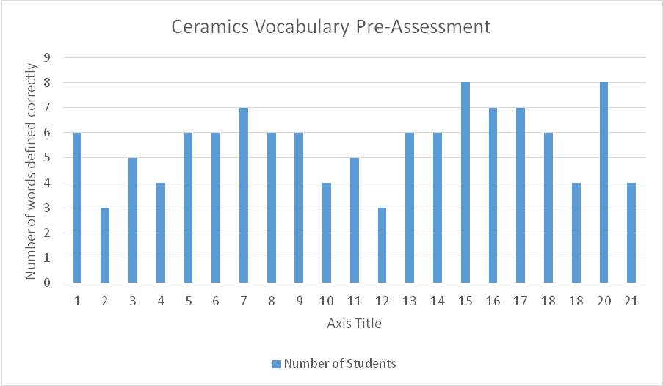
Pre-Test Mean = 6 Pre-Test Mode= 6 Pre-Test Median=5.6

Summary of Pre-Assessment Results
According to the results of the pre-assessment, only two students received passing grades, while all other students received low grades. Majority of the students retained little vocabulary definitions from the demonstration. They are all not familiar with basic vocabulary terms that need to be understood to understand this ceramics unit. I will use these results to present students with multiple opportunities to use the ceramics vocabulary. I will also have the students create their own ceramics project and take a ceramics test at the end of the unit to see how much information they have learned over this unit. I will provide multiple opportunities for students to improve their understanding of ceramics vocabulary.
Plan of Instruction
National Art Standard: 1- Understanding and applying media, techniques, and processes.
National Art Standard: 2- Using knowledge of structures and functions.
National Art Standard: 3- Choosing and evaluating a range of subject matter, symbols, and ideas.
National Art Standard: 4- Understanding the visual arts in relation to history and cultures.
National Art Standard: 5- Making connections between visual arts and other disciplines.

Ceramics Unit
Teacher Candidate: Haley Rheault
Grade: 6th Grade
Subject: Art
Theme: The 6th grade art students will be starting their ceramics unit. During this unit they will be introduced to new vocabulary about ceramics, new techniques used when working with clay, and the different parts of the kiln, in which you use to fire the clay once the projects are made. They will have multiple days to work on their project, glaze their project, and then the final day of the unit they will then be tested on the vocabulary and kiln labeling.
National Core Arts Standards http://www.nationalartsstandards.org//
State Standard(s): http://doe.sd.gov/contentstandards/
National Art Standard: 1- Understanding and applying media, techniques, and processes.
National Art Standard: 2- Using knowledge of structures and functions.
National Art Standard: 3- Choosing and evaluating a range of subject matter, symbols, and ideas.
National Art Standard: 4- Understanding the visual arts in relation to history and cultures.
National Art Standard: 5- Making connections between visual arts and other disciplines.

Goals/ Outcomes (minimum of 4 based on the NVA standards)
To demonstrate creativity using the elements of slab construction, coil construction, and pinch construction in ceramics.
To demonstrate skill and technique when constructing and modeling clay based on their personal ideas.
To develop appreciation for ceramics in one’s own and others’ works when observing their work.
To demonstrate knowledge and understanding of the kiln and the role it plays in ceramics.

Planning | Rationale: Describe how this lesson is developmentally appropriate:  - The students will gain knowledge and a better understanding for the basic concept of clay modeling.  - The students will need to be able to think creatively to meet the necessary objectives.  - The students will need to work independently and consider time management while completing their projects.  - Demonstration and hands on learning are used to deliver the content of this lesson.  - Relevance of this unit includes hands on learning, brainstorming, and imagination for the students, which can be applied in everyday situations.
Planning | Evaluation:  Pre-Assessment  - At the beginning of the unit the teacher will write the vocabulary words on the board and then have the students get out a piece of paper. The students will then write what they think the definition of each vocabulary word is. The teacher will have them hand in their definitions. By doing this the teacher is then measuring the level of understanding that each student has before they begin the unit.  Assessment  - During this unit the students will be introduced to vocabulary and techniques used in ceramics. They will take the knowledge they have obtained from the vocabulary and demonstration and apply it to their projects. They will be going over vocabulary and labeling the kiln handouts. They will be given a demonstration of what they will be doing for their projects. They will be given a few days to work on the construction of their projects and then will be given a couple days to glaze and fix any part of their project that is needed. They will then be tested on the vocabulary and kiln labeling handouts.  Post-Assessment  - The last lesson of this unit the students will be tested on how much information they have retained throughout the ceramics unit. They were given a vocabulary handout and a kiln labeling handout. They were to fill those in when the teacher went over each word and part of the kiln. Based on the scores of the test, it will show how much information the students have learned from the beginning of the unit until now.
Planning | Key Vocabulary:  Ceramics Kiln  Glaze Kiln shelf  Pinch construction Firebrick  Coil construction Peephole plug  Slab construction Heating coil  Wedging Stand/Holder  Cone Switch box  Score Cone  Bisque Firing Peep-hole  Glaze Firing Stilt  Raw  Leatherhard  Greenware  Bisqueware  Glazeware  Glossware | Technology needed:  - The teacher will present examples to the students using the internet. The teacher will display different examples on the projector screen.  - The students have access to computers and will be able to look up ideas and concepts using their computers.  Supplies:  Clay  Wedging board  Glaze  Paint brush  Garbage bags  Ice cream bucket
Planning | Accommodations:  - Accommodations were made to each individual lesson and were noted on each of those lesson plans.  Scope: and Sequence of experiences:  Lesson 1:  For this lesson the teacher will have the vocabulary words written on the board when the students come to class. The students will be asked to get their own sheet of paper and write the word and what they think the definition of the word is. The teacher will collect these. The students will then be given the actual vocabulary sheet where they will fill in the actual definition of each word after the teacher reads each one off. The students will be asked to keep the vocabulary sheets to study from for their final test.  Lesson 2:  For this lesson the teacher will be discussing the student’s projects and then demonstrating what they will be doing. At the beginning of the class the teacher will choose a table and have the students gather around that table. The teacher will explain what they will be doing and will then go over vocabulary words while quizzing the students about what each word is. The teacher will be demonstrating coil construction, slab construction, pinch construction, and then allow time for the students to practice each technique with a small amount of clay. The students will be given 3 days to work on their projects. Two full class periods of construction, and then the final day to smoothen out edges and sides while clay is bone dry. Their clay will then be bisque fired.  Lesson 3:  For this lesson the teacher will give the students a kiln labeling handout. The students will be asked to follow along as the teacher tells the students what each part of the kiln is. Once they have gone over the handout, the teacher will have the students gather around the kiln showing them the different parts and section of the kiln, while explaining what they do. Once they have covered the kiln the students will take their bisque fired pieces from the kiln and put them on the designated shelves.  Lesson 4:  The teacher will begin this lesson by having the students gather around one table. The teacher will tell the students that they will be glazing. The teacher will explain the different types of glazes to the students, some that are lead free, and the ones that are not. The teacher will explain to the students the multiple layers of glaze they must add to their piece to get the finished look they are desiring. They are then given two class periods to finish their glazing.  Lesson 5:  The students were given two handouts at the beginning of the unit, the handouts consisted of vocabulary that the students were introduced to numerous times throughout the unit. They were to be studying the vocabulary throughout the unit. They will then be given a test for this last lesson. There will be fill in the blank type of questions on the test and they will be asked to label the kiln as well.

Lesson 1: Vocabulary
Teacher Candidate: Haley Rheault
Cooperating Teacher: Mrs. Janene Harry
Grade Level: 6th Grade
Subject: Art
Date: 3/18/2016
This lesson I will be introducing the 6th grade art students to ceramics vocabulary. I will start this lesson by writing the vocab words on the board and then having the students copy them down on their own sheets of paper. I will have them write down what they think each word is and hand in their ideas. I will then be handing out the actual vocabulary sheet, along with the sheet on the kiln. I will go through those words with students as well as talking about the project we will be starting in their class. I will tell them to place their kiln labeling sheet in their folders for now.
Common Core/State Standard(s):
National Art Standard: 1- Understanding and applying media, techniques, and processes.
National Art Standard: 2- Using knowledge of structures and functions.
National Art Standard: 3- Choosing and evaluating a range of subject matter, symbols, and ideas.
National Art Standard: 4- Understanding the visual arts in relation to history and cultures.
National Art Standard: 5- Making connections between visual arts and other disciplines.

Learning Objective(s):
Students will be able to gain a better understanding for ceramics.
Students will be able to demonstrate their understanding for ceramics by filling in their vocabulary sheets.
Planning | Rationale: Describe how this lesson is developmentally appropriate:  - Basic understanding of ceramics is needed to master the lesson objectives.  - Learning about ceramics in art is useful to the students to teach them a variety of mediums.  - Basic ceramics vocabulary will be taught during this lesson with assistance from the teacher.
Planning | Pre-Assessment  - The teacher will write out the vocabulary words on the board.  - The teacher will tell the students to get out a scratch sheet of paper and write the vocab words down.  - The students will write what they think each definition is for the vocabulary words.  - The teacher will hand out a vocabulary sheet to each student and tell them to put their names in the top right hand corner.  Assessment  - The teacher will start with number one on the vocabulary sheet and go through the entire sheet with the students.  Post-Assessment  - The students will go through the entire unit working with all aspects of ceramics, using the vocabulary words given to them.  - The students will then be given a test on the vocabulary words covered in class.
Planning | Key Vocabulary:  Ceramics Greenware  Glaze Bisqueware  Pinch Construction Glazeware  Coil Construction Glostware  Slab Construction Raw  Wedging Leatherhard  Cone Slurry  Score  Bisque Firing  Glaze Firing |  | Technology needed:  - Students have access to and will be able to use their computers to look up ideas for their projects and gather more information about ceramics  Other required materials:  Pencil  Vocabulary sheets
Planning | Accommodations:  - Accommodations that could be made for this lesson for students with disabilities would include giving them a vocabulary sheet that has the definitions as a fill in the blank, so they are able to follow along and fill the words in that are missing. Another accommodation could be giving the students a vocabulary sheet that is completely filled in already with the correct definitions and have them follow along.
Lesson Plan Implementation | Lesson Opening:  - The teacher will tell the students that they are now starting a ceramics unit.  - The teacher will write all the vocabulary words on the board  - The teacher will tell the students to number their paper to 16.  - The teacher will tell the students to write down each vocabulary word and what they think the definition of that word is.  - The teacher will have the students hand in their scratch sheets of paper with their thoughts on the vocabulary words.  - The teacher will then hand out the actual vocabulary sheet to each student.
Lesson Plan Implementation | I Do | Instructional Input  - The teacher will tell the students to place their name in the upper right hand corner.  - The teacher will tell the students that they will be filling in the vocabulary worksheet with the correct definitions as the teacher reads them off.  - The teacher will tell the students that they will be then tested on these vocabulary terms at the end of the ceramic unit.  - The teacher will ask if there are any questions before they start.
Lesson Plan Implementation | We Do | Guided Practice  - The teacher will go through each definition with the students, starting with number one.  - The teacher will give the students the correct answer for each of the vocabulary words.  - The teacher will make sure that the students have every vocabulary definition written in.
Lesson Plan Implementation | You Do | Independent Practice  - The students will need to study these vocabulary words often, in order to pass the test at the end of the unit.
Lesson Plan Implementation | Lesson Closing  - The teacher will check if there are any questions or any definitions that need to be repeated.  - The teacher will remind the students that they will be tested on these vocabulary words at the end of the ceramic unit.  - The teacher will remind the students to study the vocabulary words they were just given.  - The teacher will tell the students that the next lesson will be a demonstration of what they will do for their projects.  - The teacher will tell the students that after the demonstration they will have time to work with the clay and come up with ideas for their project.
Analyze | After you have administered your assessments (formal or informal) for this lesson, analyze the results.  - Due to students testing during the week of this unit, I had split classes for the entire week. Monday and Wednesday I had half of the 6th grade class and Tuesday and Thursday I had the other half of the 6th grade class. We did not have school Friday or Monday due to Easter break. Because of having split class I had to rearrange the way I presented information to the students. Instead of giving the students formal vocabulary and then demonstration, I gave the students a demonstration and then gave them their vocabulary sheets and we filled them in.  - So this lesson took place after the demonstration. I wrote the vocabulary words out on the board and asked them to write down what they thought the definitions were and then turn them in to me. Being they were given a demonstration the class time they were there before, they had then heard the vocabulary words prior to this lesson. The informal assessment was meant to see what the students knew before we started the unit, but doing it this way was also a good test to see what information they retained during the demonstration.  - Now that the students were already introduced to the ceramics unit a day prior, I was able to see the level of understanding the students had after one lesson using the vocabulary words. The students results of this informal assessment, writing the vocabulary word definitions and then turning them in, showed that after one lesson of just hearing the vocabulary words spoken to them, they were only able to retain a few of the definitions to the vocabulary words. 43% of the students got 6 of the vocabulary words correct out of 16. None of the students received above a 50% on the informal pre-assessment.  - The vocabulary words that seemed to stick with the students were the words that I repeated multiple times during my demonstration. Such words were the techniques I introduced to them, such as pinch construction, coil construction, and slab construction. As well as wedging, wedging board, and slurry.  - The grade of the informal pre-assessment will not affect the student’s final grade. They will have access to their vocabulary sheets for two weeks to study from before they take their final ceramics test worth 30 points.
Reflect | Reflect on your effectiveness as a teacher based on the analysis of students’ performance.  - I was unaware of the testing that the students were going to be having, so I wasn’t at first prepared to have the split classes. It ended up working in my favor, because students were looking for something hands on to release their energy from the testing. Instead of trying to retain information after looking at a computer screen all day, these students were full of energy and excited to be building something out of clay. The planning a ceramics unit during this time was a good idea. If I would have been giving the students the vocabulary, I don’t think the information would have stuck as well. So one thing I feel I did well was planning a ceramics unit during this time frame.  - Another thing that I feel I did well during this lesson is allowing the students to come up with their own definitions at first before giving them the actual definition. By doing this they were then able to think rationally and come up with things on their own. So many times do students just get the definitions handed to them without having to think about them on their own. Having them think about things without looking them up on the internet allows them to retain the information better and be able to think rationally on their own.  - One thing that I would change for this lesson would be to incorporate the procedures into a handout or even show video clips of them. I would type a list of what is expected of them or show them video clips and they would then practice the steps and check them off as they doing them. This way the students would know what is going to be expected of them before they begin the unit. They would know where all materials go, what they need out for the clay, and how clean up needs to go for them as well.

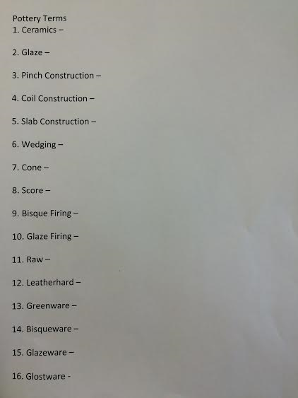

Ceramics demonstration
Teacher Candidate: Haley Rheault
Cooperating Teacher: Mrs. Janene Harry
Grade Level: 6th
Subject: Art
Date: 3/21/2016
During this lesson I will be giving a demonstration to the students, on their ceramics project. I will have the students gather around one table and go over vocab they will be given, while demonstrating what they need to do. I will cover slab construction, coil construction, and pinch construction, along with the different vocabulary that goes along with ceramics.
Common Core/State Standard(s):
National Art Standard: 1- Understanding and applying media, techniques, and processes.
National Art Standard: 2- Using knowledge of structures and functions.
National Art Standard: 3- Choosing and evaluating a range of subject matter, symbols, and ideas.
National Art Standard: 4- Understanding the visual arts in relation to history and cultures.
National Art Standard: 5- Making connections between visual arts and other disciplines.

Learning Objective(s):
Students will be able to demonstrate their knowledge in ceramics by completing their clay project.
Students will be able to gain a better understating for the multiple techniques used in ceramics.
Students will be able to make a connection between what is demonstrated and their own clay project.

Planning | Rationale: Describe how this lesson is developmentally appropriate:  - Basic understanding of ceramics is needed to master this lesson.  - Basic techniques in clay construction is needed to master this lesson.  - Learning about ceramics in art is beneficial to students by allowing them a way to be hands on.  - Demonstration of basic clay construction will be taught during this lesson with assistance from the teacher.
Planning | Pre-Assessment  - The teacher will have the students gather around a table to complete a demonstration, going over vocabulary the will need to know for the test, as well as the different clay construction techniques.  Assessment  - The students will take the knowledge obtained during the demonstration and complete their own project, based on the three construction techniques learned.  - The students will be allowed three class days to work on the construction of their clay project.  Post-Assessment  - The students will be graded on the construction of their project, the idea and difficulty of their project, and the design or decoration they added to their projects. This project will be graded out of 100 points.
Planning | Key Vocabulary:  Ceramics  Pinch construction  Coil construction  Slab construction  Wedging  Wedging board  Score  Slurry  Leatherhard |  | Technology needed:  - Students have access to and will be able to use their computers to look up ideas for their projects and gather more information about ceramics.  Other required materials:  Clay ceramic tools  Water wedging board  Garbage bags
Planning | Accommodations:  - Accommodations for this lesson that would be made for students with disabilities, would be to allow students to have a hand out of the different styles of construction- coil construction, slab construction, pinch construction, which would show multiple examples of pinch construction, slab construction, and coil construction. Allowing the student to see examples will help them in the construction of their own project.
Lesson Plan Implementation | Lesson Opening:  - As the students enter the classroom the teacher will tell them to place all of their belongings on one certain table.  - The teacher will tell the students that they will be watching a demonstration and then starting their own clay projects.  - The teacher will tell the students to sit quietly, and will then dismiss the students to come join around a table for demonstration.  - The students will gather around one table for a demonstration.
Lesson Plan Implementation | I Do | Instructional Input  - The teacher will ask the students what they think the definition of ceramics is.  - The teacher will explain to the students that they will be constructing a creative piece using pinch construction, slab construction, and/or coil construction.  - The teacher will show the students that they will use a kneading board to knead their clay.  - The teacher will ask the students why they must knead clay before starting to model it into their project.  - The teacher will demonstrate how the students should knead clay using their palm and full hand instead of just their fingertips.  Coil Construction  - The teacher will ask the students what they think the definition of coil construction is.  - The teacher will demonstrate how students will roll out a coil using the palm of their hands.  - The teacher will tell the students what slurry is and why it is needed.  - The teacher will then tell the students what score is and why they must score their piece.  - The teacher will show students how to score a piece of clay and apply slurry to attach two pieces of clay to one another.  - The teacher will tell the students that it is very important to slurry and score their pieces of clay before putting them together or they will not stay together when dry or in the kiln.  - The teacher will show the students many different styles of coils that the students can roll out.  Pinch Construction  - The teacher will ask the students what they think pinch construction is.  - The teacher will show the students how to roll clay out into a ball.  - The teacher will show the students how to keep pinching the clay to get a shape made out of the ball of clay.  - The teacher will show the students that they need to be sure and hollow out all of their pieces of clay so when they are fired in the kiln they will not explode.  Slab Construction  - The teacher will ask the students what they think slab construction is.  - The teacher will show the students how to roll out a slab of clay using a rolling pin and two rulers stacked on each side to get the correct width of clay.  - The teacher will ask the students what needs to be done to connect two slabs together.  - The teacher will show the students again to apply score and slurry to connect two pieces  - The teacher will show the students how to roll out a small coil to place in the inside of the two slab pieces, and then smoothen that coil with their fingernail to make it look finished.
Lesson Plan Implementation | We Do | Guided Practice  - The teacher will ask the students what the first thing to do is once they have gotten their wedging board and clay.  - The teacher will then ask the students what the three different constructing techniques they covered were – coil construction, slab construction, and pinch construction.  - The teacher will ask the students what score and slurry is and why it is important.  - The teacher will ask the students why the clay must be hollowed out before going into the kiln.  - The teacher will dismiss students back to their seats.  - The teacher will give the students a small amount of clay to work with and experiment with.  - The teacher will ask if there are any questions.
Lesson Plan Implementation | You Do | Independent Practice  - The teacher will let the students experiment with the small amount of clay for the remainder of the class time.  - The teacher will tell the students to place their clay in a covered bucket to keep it moist overnight.  - The teacher will tell the students that tomorrow they will be starting their official clay project.
Lesson Plan Implementation | Lesson Closing  - The teacher will have the students place their clay in their buckets that they were given the class before and tell them to put their buckets in a specific area.  - The teacher will have the students place their slurry buckets in a specific area.  - The teacher will have the students scrape off their wedging boards and put them away.  - The teacher will have the students fold up their garbage bags that were used to keep the tables clean.  - The teacher will have the students sponge their tables clean.  - While the students are cleaning up the teacher will ask the one more time what the three types of construction are –coil construction, slab construction, and pinch construction, and remind them that tomorrow they will be working on their official project.
Analyze | After you have administered your assessments (formal or informal) for this lesson, analyze the results.  - Due to students testing during the week of this unit, I had split classes for the entire week. Monday and Wednesday I had half of the 6th grade class and Tuesday and Thursday I had the other half of the 6th grade class. We did not have school Friday or Monday due to Easter break. Because of having split class I had to rearrange the way I presented information to the students.  - Instead of giving the students their vocabulary first I gave them a demonstration on the first day of this unit. My initial plan was for the students to have been familiar with the vocabulary and then quiz them while I went through and demonstrated. Even though the students did not know every single vocabulary term, I was still able to show them a physical example and then quiz them while I was going through and demonstrating.  - Once I was done demonstrating I quizzed the students and asked them what certain things were and their definitions. Things like wedging, wedging board, score, slurry, slab, coil, and pinch construction, as well as what the definition of ceramics was. This was an informal assessment that could help me check the level of understanding students had after I demonstrated. About 50% of the students knew what the definitions were or what each term was for. Those students seemed to appear like I had their full attention and were listening very well. This showed when it came to me quizzing them on different terms and definitions.  - Overall the student’s projects turned out very good. Not one project was alike and every project had some unique design on it. Some students used a variety of the three techniques I showed them and some used just one of the techniques. The students really enjoyed the project and looked forward to this unit every day they came into class. Being they were testing this was the perfect unit to choose so they were able to be hands on and work some of the energy they had out.  - The students will be graded on their final project. They will be graded on the construction, idea/difficulty, and their design/decoration. The grade will be out of 100 points.
Reflect | Reflect on your effectiveness as a teacher based on the analysis of students’ performance.  - During this lesson one thing I felt I did well was planning when the unit was going to happen. It took place when the weather wasn’t very nice so we were able to run the kiln without overheating the classroom, as well as having something hands on for the students to do during the testing. Also I felt I did well walking around the classroom and helping any student who needed assistance as well as checking in with every student to see how their projects were going. I was able to assist the students who were having trouble working with the clay being it was their first time working with it.  - Another thing that I feel I did well in was giving the students a demonstration of what I expect their projects to be like. I had all the students gather around the table and showed them what they were going to be doing for their project. I was able to show them how to wedge clay, on a wedging board, apply score and slurry to pieces they will be connecting, and show them the three kinds of techniques they were able to choose from for the project. While I was demonstrating I was quizzing the students on what types of techniques I was using as well as the specific things I was doing such as wedging and applying score and slurry. I feel for that reason the students were able to remember those vocabulary words.  - If I were to teach this lesson again I would make some examples prior to the lesson to show them step by step what the clay will look like and feel like. I would also use the projector to project different ideas and projects on the projector screen so students have some ideas on how to start their projects. I would also be sure and give the students a size requirement. Some student’s projects were a lot smaller than others which I felt, for the time given to them they should have been able to make things a bit larger.

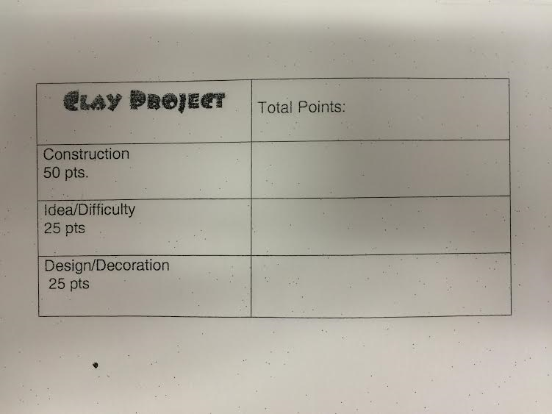

Kiln Lesson 3
Teacher Candidate: Haley Rheault
Cooperating Teacher: Mrs. Janene Harry
Grade Level: 6th
Subject: Art
Date:3/29/2016
During this lesson the students will be given a hand out of the kiln and the different parts they need to fill in. I will go over each part telling them what it’s called and what it does. After we have filled the vocab sheets out I will bring the students over to the kiln to show them the different parts and vocab we had just gone over. After we are done with that the students’ pieces should be completely dry, from sitting out for a day or so, and will be ready to fire. They will then be given 15 min to smooth out sides and edges of their projects, using water, so that their clay looks and feels finished. When they are done smoothing out the sides they will bring their projects over to me at the kiln.
Common Core/State Standard(s):
National Art Standard: 1- Understanding and applying media, techniques, and processes.
National Art Standard: 2- Using knowledge of structures and functions.
National Art Standard: 3- Choosing and evaluating a range of subject matter, symbols, and ideas.
National Art Standard: 4- Understanding the visual arts in relation to history and cultures.
National Art Standard: 5- Making connections between visual arts and other disciplines.

Learning Objective(s):
Students will be able to demonstrate their knowledge of the kiln and how it works.
Students will be able to make a connection between what is demonstrated and explained with the kiln, to their projects and what will happen after they are fired.
Students will be able to gain a better understanding for ceramics and the multiple parts and steps that go along with it.

Planning | Rationale: Describe how this lesson is developmentally appropriate:  - Basic understanding of the kiln used in ceramics is needed to master this lesson.  - Basic vocabulary of the kiln and its different pieces is needed to master this lesson.  - Demonstration of vocabulary and the kiln will be taught during this lesson with assistance from the teacher.
Planning | Pre-Assessment  - The students will have completed their clay project prior to this lesson.  - The students’ clay projects should be bone dry by this lesson.  - The teacher will give each student a hand out of the kiln and tell them to write their names in the top right hand corner of their paper.  Assessment  - The teacher will be going over the hand out with the students labeling the kiln and describing each of the parts of the kiln as they go through the sheet.  - The teacher will have the students gather around the kiln to label and show different parts.  - The teacher will allow to students to smoothen out their bone dry project.  Post-Assessment  - Students will need to make sure their project has the “finished” look by going through and smoothing the edges.  - The students will need to study their vocab on the kiln for their test.
Planning | Key Vocabulary:  Kiln  Kiln Shelf  Firebrick  Heating coil  Stand/holder  Switch box  Cone  Peep hole  Peep hole plug  Stilt |  | Technology needed:  - Students have access to and will be able to use their computers to look up any definitions.  Other required materials:  Water  Pencil
Planning | Accommodations:  - Accommodations that could be made for this lesson would be to allow students with disabilities to have a vocab sheet that is already filled in with the kiln parts. That way they would be able to follow along as you go through each part that needs to be labeled and they will be able to make the connection by physically seeing what you are going over on the kiln as well.
Lesson Plan Implementation | Lesson Opening:  - The teacher will give each student a hand out on the labeling of the kiln.  - The teacher will tell each student to put their names on the sheet and to make sure they keep this as a study guide for their test.
Lesson Plan Implementation | I Do | Instructional Input  - The teacher will go over each part of the kiln on the hand out.  - The teacher will tell the students what each part is and what it does.  - The teacher will check with the students before moving on to make sure that they have each of the parts of the kiln labeled.
Lesson Plan Implementation | We Do | Guided Practice  - The teacher will then bring the students over to the kiln and go over with them what each part of the kiln is.  - The teacher will show the students each specific part and ask them what that part is called.  - The teacher will do a final review after everything has been covered.  - The teacher will tell the students to make sure they are studying each of the parts for their ceramics unit test.
Lesson Plan Implementation | You Do | Independent Practice  - The teacher will allow the remainder of the time for students to take water and smoothen out the edges of their pieces.  - The teacher will have one student from each table grab a bucket of water to use for their projects.  - The students will make sure their projects have the “finished” look.
Lesson Plan Implementation | Lesson Closing  - The teacher will have the students bring their projects to the kiln so they can be fired for the first time.  - The teacher will remind the students to be looking over their vocabulary and kiln handouts because they will be tested on the material at the end of the unit.
Analyze | After you have administered your assessments (formal or informal) for this lesson, analyze the results.  - By the time I was introduced the students to the kiln, they were done testing and I had the entire group back together. At this time the students projects had time to dry all the way out and were about to be fired for the first time. I gave each student a kiln labeling handout and we went through together guessing what each part was and what the actual term was for each specific piece. Once we had gone entirely though the handout I then had the students gather around the kiln. While we were all gathered around the kiln I quizzed the students on what each specific part was and even asked if they were able to guess what each part did on the kiln.  - This was a great informal assessment to check the level of understanding each student had for the kiln and how it operates. The students did well when labeling the parts of the kiln and even with the explaining of what each part did for their clay projects.  - After gauging the level of understanding of each of the students I felt comfortable that they would have no problem with this section of their test, where they are to label the specific parts of the kiln.  - The labeling of the kiln will be about half of the 30 points on their tests that will be given to them at the end of the unit.
Reflect | Reflect on your effectiveness as a teacher based on the analysis of students’ performance.  - The first thing that I felt I did well on during this lesson was the gathering of the students around the kiln and quizzing them on the different parts of the kiln and what they did. It was a good way for the students to see a physical example of the kiln instead of just the example they had on their papers. Students seem to gain more knowledge when they are shown a physical examples and are to come up with ideas on their own. Having students guess what each part on the kiln did was also good for their critical thinking skills.  - Another thing that I felt I did well for this lesson was the level of organization and classroom management. After the students were with me at the kiln they were then dismissed back to their seats. Once they had all of their items put away and were sitting quietly I dismissed them by table to grab their projects and bring them to me back at the kiln. Once they had given me their projects and I placed them in the kiln they were then dismissed from class. This was a good technique for organization because you didn’t have the entire class waiting in the back of the room by the kiln while you’re trying to load it. It was also a good idea for classroom management. Other students were seeing that having their stuff put away and being quiet was what I was looking for so they would then do the same thing so they were able to be dismissed from class before other students. Also giving the students step by step directions and what they are supposed to do next, leaves little room for fooling around and misbehaving.  - If I were to teach this lesson again I feel I would try and give students time at the end of the class to find a partner and study their vocabulary as well as the kiln labeling worksheet. Giving them time to study with a partner would ensure me that they are indeed studying and that they are better understanding the information before we were to test on the material.

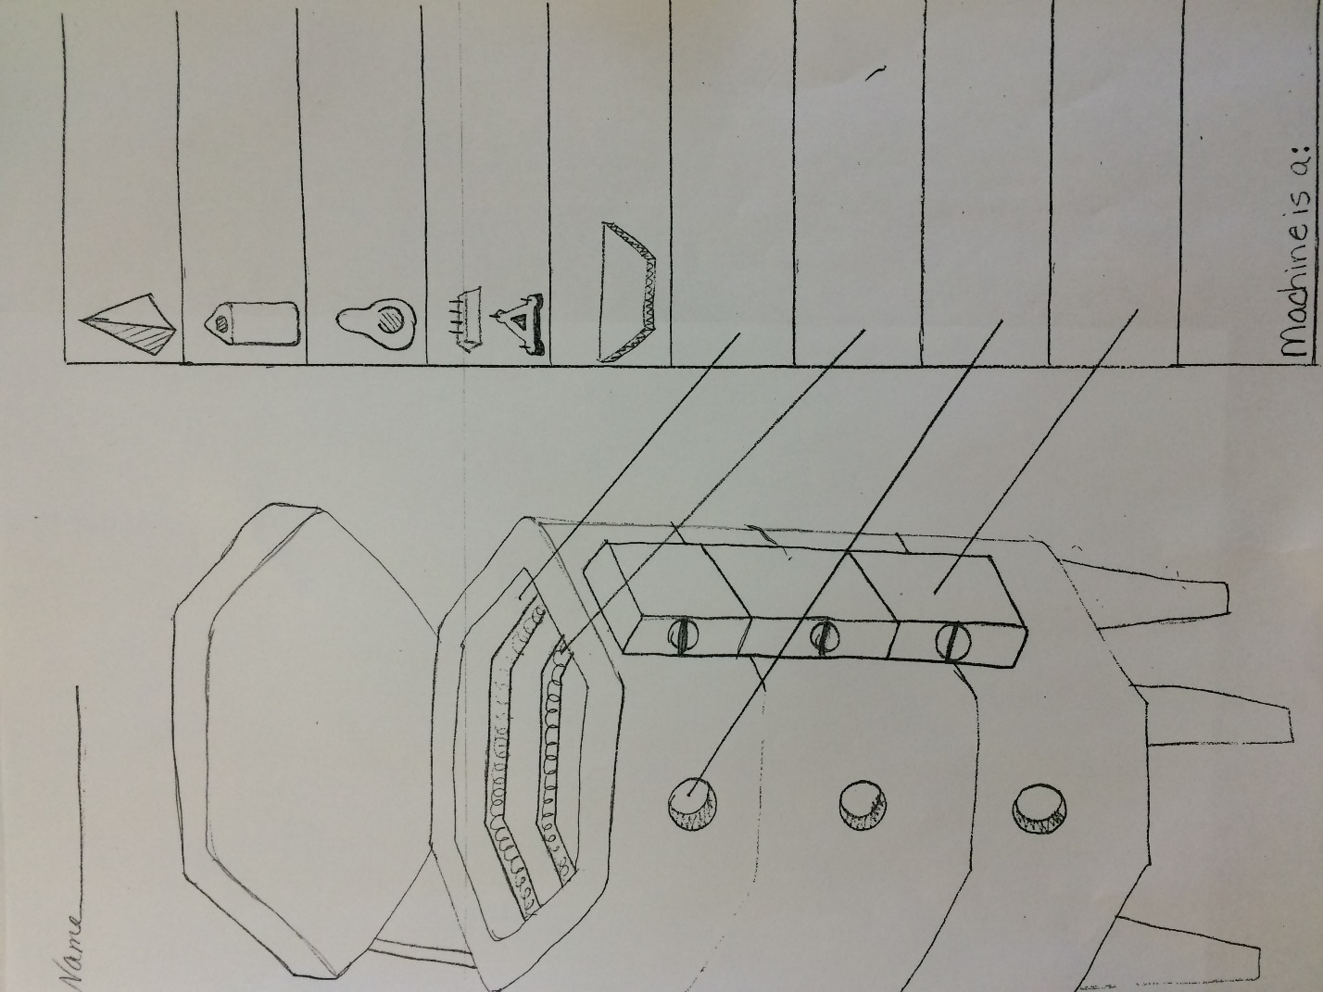

Glazing Lesson 4
Teacher Candidate: Haley Rheault
Cooperating Teacher: Mrs. Janene Harry
Grade Level: 6th
Subject: Art
Date: 3/31/2016
During this lesson I will be explaining to students the different glazes they can use on their piece, along with demonstrating how to apply the glaze to their piece. They will then be given time to work on glazing their piece. They will be given two class times to glaze.
Common Core/State Standard(s):
National Art Standard: 1- Understanding and applying media, techniques, and processes.
National Art Standard: 2- Using knowledge of structures and functions.
National Art Standard: 3- Choosing and evaluating a range of subject matter, symbols, and ideas.
National Art Standard: 4- Understanding the visual arts in relation to history and cultures.
National Art Standard: 5- Making connections between visual arts and other disciplines.

Learning Objective(s):
Students will be able to demonstrate their knowledge of glaze and the different types of glaze.
Students will be able to make a connection between what is demonstrated and explained and applying glaze to their own projects.
Students will be able to gain a better understanding for glaze and multiple techniques used when glazing.

Planning | Rationale: Describe how this lesson is developmentally appropriate:  - Basic understanding of ceramics and glazes used in ceramics is needed to master this lesson.  - Basic techniques in glazing clay is needed to master this lesson.  - Demonstration of basic clay construction will be taught during this lesson with assistance from the teacher.
Planning | Pre-Assessment  - The teacher will get out all of the different kinds of glazes from the cupboard and begin to explain the types of glazes to the students.  Assessment  - The teacher will demonstrate to the students, how the glaze will be applied and how many coats of glaze needs to be applied in order to get the correct color.  Post-Assessment  - The students will then glaze their projects that have been bisque fired.  - The students will bring their projects to the kiln, after they have glazed them, to be fired one last time.
Planning | Key Vocabulary:  Glaze  Bisque firing  Glaze firing  Bisqueware  Glazeware  Kiln |  | Technology needed:  - Students have access to and will be able to use their computers to look up ideas for glazing their projects and gather more information about ceramics.  Other required materials:  Glaze  Paintbrush
Planning | Accommodations:  - Accommodations that could be made for this lesson could be allowing the students only certain colors or kinds of glaze. Kinds that are lead free. Also giving the students a larger paintbrush to ensure that glaze covers the entire piece, and takes less time to glaze completely.
Lesson Plan Implementation | Lesson Opening:  - The teacher will tell the students that they will be glazing.  - The teacher will ask the students what glaze is, liquid glass, which is from their vocabulary sheet.  - The teacher will tell the students that they will be graded on their construction, idea, and the design and decoration of their projects. This includes their glazing.
Lesson Plan Implementation | I Do | Instructional Input  - The teacher will show the students the different brands of glaze, such as the AMACO lead free glaze and the mayco glaze.  - The teacher will explain to the students that if they plan to use their project to be able to put food or drinks in, the must use lead free glaze.  - The teacher will tell the students that if they do plan to use their projects for food or drink, they must be hand washed not in the dishwasher.  - The teacher will tell the students that the color of the glaze will appear much different from what it looks like currently.  - The teacher will show the students other examples and colors they used and how they have change and gotten a much more glossy look.  - The teacher will show the students a color guide in a magazine of how the glazed colors will turn out after being fired.  - The teacher will tell the students that they must apply the glaze 2-3 times so it appears the correct color that they are trying to achieve.  - The teacher will then ask the students if there are any questions.  - The teacher will ask the students’ one more time how many layers of glaze they need to put on their piece to achieve the color in the magazine.
Lesson Plan Implementation | We Do | Guided Practice  - The students will then pick out what color or colors of glaze they would like to use for their project.  - The teacher will call the students table by table to get paint brushes.  - The teacher will call them table by table to come up and get the glazes.  - If a student chooses the same glaze as someone else, they are allowed to sit next to that person and share the glaze.
Lesson Plan Implementation | You Do | Independent Practice  - The students will then start glazing their piece.  - They will be reminded throughout the hour that they must apply 2-3 even coats of glaze and make sure that they cover the entire piece.
Lesson Plan Implementation | Lesson Closing  - The teacher will remind the students that they are allowed two class period to glaze their projects.  - They will then need to bring their projects to the kiln to be glaze fired.  - The teacher will remind the students that they will have a test on the vocabulary and kiln worksheets the following class, so they need to be studying.
Analyze | After you have administered your assessments (formal or informal) for this lesson, analyze the results.  - During this lesson I was introducing the students to glaze and what glaze is in ceramics. I explained the two different kinds of glaze that were used in the classroom and explained and showed them how many layers of glaze need to be applied to get the final end result they are looking for. While I was instructing the students and demonstrating I was sure to quiz them on the different kinds of glaze and how many times they were to apply the glaze. This informal instruction was a good way to measure the amount of knowledge that the students were getting during my demonstration.  - All of the students answered back with the correct answer of three layers of glaze and of why they need to put that many layers of glaze on their piece. I felt that I did a good job of making sure that the students got that in their head and would remember the number of layers of glaze needed to get the glossy finished look.  - The students really seemed to understand this lesson on glazing and seemed to do well adding the three layers of glaze to their piece. Majority of the students pieces came out very nicely glazed and had more than one color covering the entire piece.  - It was at first hard for the students to really see what the glaze color was going to be, being the glaze looks nothing like the finished product, but once I showed them the color examples they trusted me and were very happy with the outcome of their projects and the colors that they turned out to be.
Reflect | Reflect on your effectiveness as a teacher based on the analysis of students’ performance.  - The first thing that I feel I did well with this lesson was having the students gather around a table and explaining to them the process of glazing to them. I showed them how the glaze will go on and how it will look after they have it fired. They all seemed surprised how different it looked, but I was able to give them a good idea of what to expect. Showing them finished examples and examples in a magazine helped for them to picture what it would look like on their project.  - I also feel like I did a good job allowing the students their own choice of what they want to do for their glaze. I didn’t tell them what to do but I allowed them to choose the colors and styles of glaze they added to their piece. I feel giving the students freedom to do things how they want allows them to think deeper about their own projects. Allowing them that freedom really gets them excited about working on their projects.  - If I were to teach this lesson again I would have the student a bit more time to come up with more than one project. I feel that if they were to work with the clay a bit longer they would have better outcomes and would have more practice with the clay as well as the glazes. A lot of the students wanted to try multiple glazes but ran out of room on their projects to do so. If they would be able to make a couple projects they would then have more opportunities to be creative with their glaze and to try other colors or designs with them.

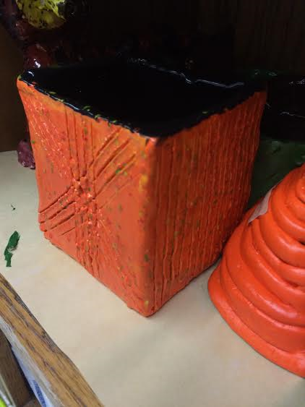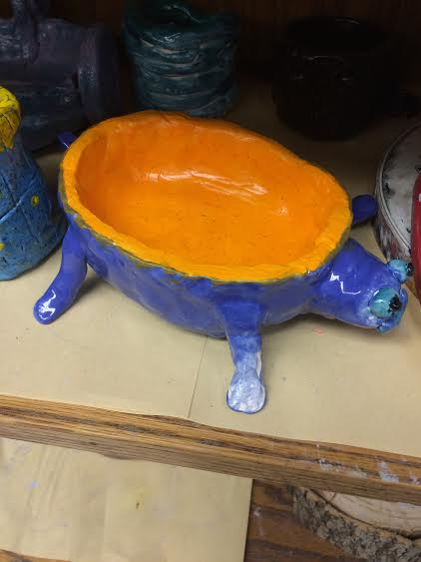

Ceramics Test
Teacher Candidate: Haley Rheault
Cooperating Teacher: Mrs. Janene Harry
Grade Level: 6th
Subject: Art
Date: 4/1/2016
During this lesson I will be giving the 6th grade students in ceramics their ceramics test. The students were given vocabulary sheets and a labeling sheet of the kiln that they were to study before the test. Before the test I will be sure to collect the student’s vocabulary sheets to prevent any wondering eyes and cheating. They will also put up folders around their test for privacy.
Common Core/State Standard(s):
National Art Standard: 1- Understanding and applying media, techniques, and processes.
National Art Standard: 2- Using knowledge of structures and functions.
National Art Standard: 3- Choosing and evaluating a range of subject matter, symbols, and ideas.
National Art Standard: 4- Understanding the visual arts in relation to history and cultures.
National Art Standard: 5- Making connections between visual arts and other disciplines.

Learning Objective(s):
Students will be able to demonstrate their knowledge in ceramics by completing their ceramics test.
Students will be able to gain a better understanding for the kiln and different techniques and styles of ceramics during their test.
Students will be able to make a connection between what has been learned and demonstrated in ceramics./

Planning | Rationale: Describe how this lesson is developmentally appropriate:  - Basic understanding of ceramics is needed to master this lesson.  - Basic understanding of clay techniques is needed to master this lesson.  - Basic understanding of the kiln is needed to master this lesson.  - Learning about ceramics and having a test over the material is beneficial to students to find out their level of understanding.
Planning | Pre-Assessment  - Students will be given the first 5-10 minutes of class to study their vocabulary sheet and kiln labeling handout.  - The teacher will then ask a few practice questions that may be seen on the test, for the students to be thinking about before taking their test.  Assessment  - The students will then begin taking their ceramics test.  - There will be a front and a back to the ceramics test with 30 questions.  Post-Assessment  - The students will hand in their test when complete.  - The students will be graded on the number of questions answered correctly out of 30 points.
Planning | Key Vocabulary:  Ceramics  Kiln  Kiln shelf  firebrick  Peep hole  Peep hole plug  Heating coil  Stand/holder  Switch box  Cone  Stilt  Leatherhard  Score |  | Technology needed:  - Students have access to and were able to use their computers to study for the test.  - They will not be able to use the computers or any technology during the test.  Other required materials:  Paper  Pencil
Planning | Accommodations:  - Accommodations that could be made for students with disabilities would be to allow them to take their test in a quiet area away from other students, such as a resource room.  - Another accommodation that could be made would be to allow the students a word bank to find the vocabulary words for each question on the test.
Lesson Plan Implementation | Lesson Opening:  - The teacher will allow the students 5-10 minutes right at the beginning of class to study their vocabulary and kiln labeling handouts.  - The teacher will then collect the students’ handouts.
Lesson Plan Implementation | I Do | Instructional Input  - The teacher will then go over a few practice questions from the test, with the students.  - The teacher will read a question and then call on a student raising their hands who thinks they have the answer.  - The teacher will only spend a few minutes on this to allow for students to have time to complete their test.
Lesson Plan Implementation | We Do | Guided Practice  - The teacher will tell the students to come up and grab a folder to put up for privacy during the test.  - Every student will have a folder to hide their tests from others.  - The teacher will then hand out the test.  - The teacher will tell the students to be sure and put their names on their test.
Lesson Plan Implementation | You Do | Independent Practice  - The teacher will be sure to keep the room quiet.  - The students will start to take their test.  - The students will be given the remainder of the class to finish the test.  - The teacher will walk around the room monitoring the students.  - The teacher will answer questions that the students may have about the test, without giving answers.
Lesson Plan Implementation | Lesson Closing  - The students will then hand in their tests.  - The students will be graded on how many questions they answered correctly out of 30.
Analyze | After you have administered your assessments (formal or informal) for this lesson, analyze the results.  - The students were given two handouts at the beginning of the unit and were given the vocabulary words with the correct definitions of those words. The students were given two weeks to study their two hand outs, the vocabulary and the kiln labeling. They had their own time to study as well as time in class when we would go over the words and the kiln labeling. There were two days that the handouts were introduced to the students and then two other class times where I went over the words and helped the students study. I differentiated the ways that I went over the handouts with the students. Those included drawing the kiln out on the board and having students raise their hands and come up and label the kiln, as well as reading definitions and having students tell me the vocabulary words. Differentiating the way the information is given to the students I feel benefited them on the test.  - The test was out of 30 points, 16 vocabulary words and 10 kiln labeling. All questions but four were worth 1 point, and those four were worth 2 points. The students seemed to do very well on the assessment. Not one student got a grade below a 60%. Only one student got the grade of a 60%. Five students received 93% and three students received a 100% on the test.  - How did the students perform on this assessment? To what degree did they achieve mastery toward the lesson objective(s)?  - How will you provide opportunities for remediation and extension?
Reflect | Reflect on your effectiveness as a teacher based on the analysis of students’ performance.  - The first thing I feel I did well on for this lesson was preparing the students for the exam. They were given the vocabulary handouts at least two weeks ahead of time and had time in class to study for this test. I differentiated the ways I gave the students the information and had them work on it on their own time as well. I feel I did this well because not every student learns the same so differentiating the instruction and the information they need to know is beneficial to them and the results of the pre-test.  - Another thing I feel I did well was giving the students plenty of time to take the test. I didn’t want the students to feel like they were rushed for time and had to guess on questions. Giving them the amount of time I did, I feel was beneficial to reduce the amount of guessing that took place. The outcome of the test was a good one so I feel that giving them that whole hour of class time for the test was beneficial. I also was sure to make sure they had privacy folders up so that their eyes didn’t wander and they didn’t have to worry about anyone else’s eyes wandering to their paper.  - If I were to change this lesson I would make the test worth a bit more and make it a bit longer. I would do this so that these young 6th grade students would learn to realize how important studying really is. I gave them class time to study, but a lot of the studying that took place should have been on their own time. I would make the test a larger part of their grade to make them realize how important it really is to study and take care of things on their own time instead of just in the time that I had given them. If I were to do this I wouldn’t make the score outrageous. I would make it out of 50, which is the same as some of their larger projects, this way they take it a bit more serious when they are looking at it affect that part of their grades.

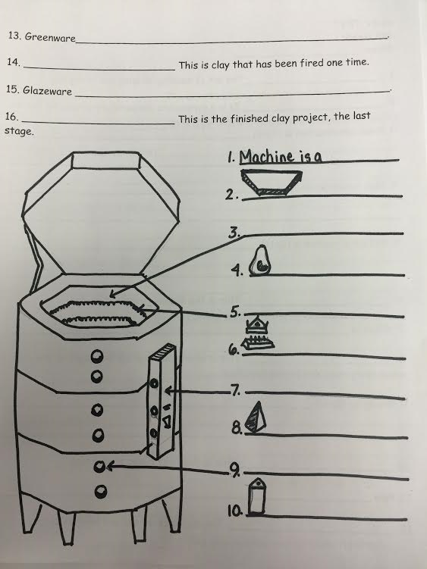
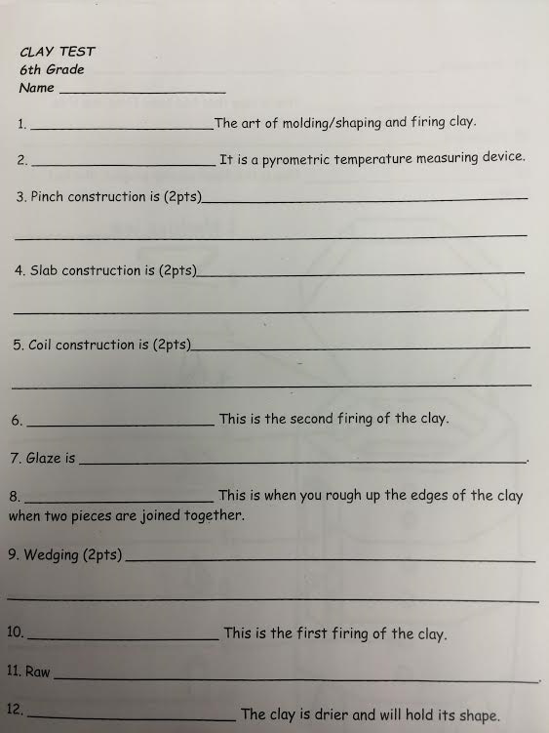

V. Analysis of Student Learning (due by week 10)
Task: Candidates analyze the assessment data, including pre/post assessments, to determine students’ progress related to the learning objectives. (see Documenting Student Learning handout)

- Analyze the progress of the whole class, subgroups (e.g., gender, performance level, etc.) and/or individuals by creating a table or chart that shows pre- and post- assessment data overall.
- Discuss the extent to which your students made progress (from pre- to post-) toward the learning objectives.
- Explain the factors that may have influenced the results.

After instruction
This unit was a ceramics based unit where students were given vocabulary, a demonstration, and then were to create their own projects based on three techniques taught in class. Once they had created their own projects, they were then tested on the material given to them throughout the unit. The test was 26 questions, 16 vocabulary, and 10 kiln labeling. The test was worth 30 points, thus making four of the questions worth two points.
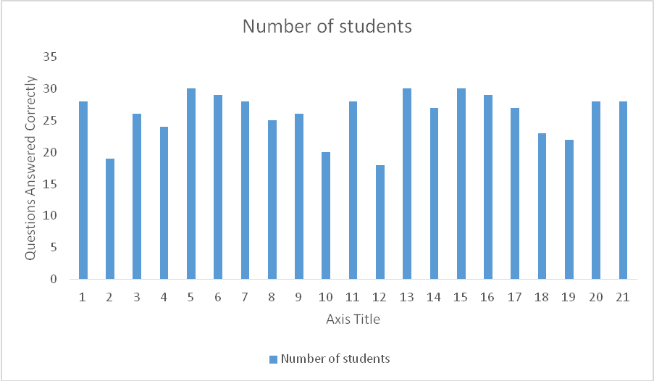

Post-Test Mean= 25.9 Post-Test Mode= 28 Post-Test Median= 27

The results of the post-assessment on vocabulary and kiln labeling was that three students received 100%. None of the students received a 50% or lower, although one student did receive a 60%. The students were given class time to study for the exam and were also shown the vocabulary and kiln parts multiple times during class. This was a good way for the student to practice and get a better understanding of the vocabulary and kiln.
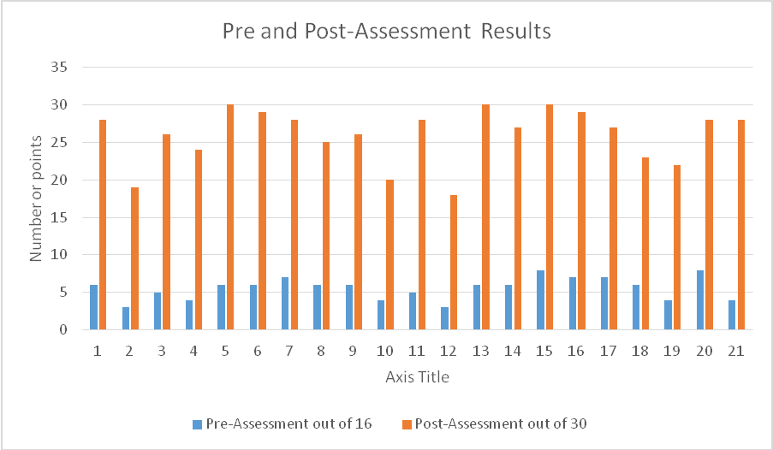
The students made significant gains in their post-assessment compared to their pre-assessment; the majority of students improved their score greatly. Based on the pre-assessment students had very little understanding of ceramics and the vocabulary that goes along with ceramics. The students were not familiar with the common terms used in relation to ceramics. In the post-assessment students displayed an understanding of the vocabulary terms, averaging 6 out of 16 correctly defined terms. Students also showed that they had developed an understanding of the kiln and the parts that go along with the kiln. The lowest score received on the post-assessment was a 60% and the highest was 100%. This could have been because students did not study as well as other students had. The results although, suggest that the students did in fact learn throughout the unit and developed a deeper understanding of ceramics.
The assessments I gave were valid in the fact that they measured the objectives that I was attempting to evaluate. I gave a variety of different types of instruction to reach multiple learners, including the chances to gain knowledge of terms while creating their own ceramics project. Students were instructed with a basic handout of vocabulary and demonstration. I also provided instruction by working with the student’s one on one to help them finish their ceramic projects. For the performance task I asked the students to develop their own ceramics project based on the three types of instruction given to them; coil construction, slab construction, and pinch construction. This assessment is valid and relates directly back to what was being taught and the objectives for this unit.

VI. Reflection and Self-Evaluation- Goals (due by week 10)
Task: Candidates reflect and evaluate progress toward personal and professional goals.
- Goal, Procedure, Evaluation: For each category of NSU’s School of
Education’s Conceptual Framework, you will write a goal, procedure and method of evaluating whether or not you have achieved your goal. Goals should be specific to this experience and may build on goals from Junior Field experiences. Refer to the Final Student Teaching Evaluation rubric when setting these goals.
  - Knowledge of Self as an Individual
  - Knowledge of the Learner
  - Knowledge of Content
  - Knowledge of Pedagogy
  - Knowledge of Self as a Teacher and Member of a Learning Community

Candidates must use the following format:
Goal: During this experience, I will… (Consider your strengths and weaknesses in this area and refer to the Conceptual Framework to ensure your goal relates to the expectations of this area.)
Procedure: I will accomplish this goal by… (Clearly and thoughtfully tell how you will go about working toward this goal. Be specific.)
Evaluation: I will evaluate this goal by… (Explain how you will measure attainment of the goal)

I. Knowledge of Self as an Individual
Goal:
I will speak to my students articulately and professional, while expressing appropriate communication skills through eliminating using the term “you guys”.

Procedure:
I will accomplish this goal by practicing and repeating what I am going to say, as well as going over my lesson and what I am going to introduce to the students in class before I give each lesson. I will work on my word choice in class by saying “ladies and gentlemen,” or “class,” instead of saying “you guys”. I will also try and slow down when speaking, in order to speak clearer to the students, as well as refrain from using words such as: “um,” yeah,” and “so”.

Evaluation:
I will evaluate this goal by accumulating the number of times I use the term “you guys” after each lesson. I will compare the number from my first lesson to my last. I will also have my cooperating teacher help me recognize if I say any of those filler words, along with using the term “you guys”. With that I will have my cooperating teacher monitor my tone, speed, and volume while giving my lesson.
Reflection:
During my lessons and the time I was teaching I did not catch myself using the terms “you guys”, “um”, “yeah”, and “so”. I also felt that I spoke at a speed that the students could keep up with and could understand. I feel that I was able to achieve these goals based on the amount of practice I completed with each of my lessons. Knowing what I am going to say helps eliminate the use of those terms, as well as keeping the speed of my lessons at the right pace for my students. I also had a greater understanding of the materials I was going to teach within my lessons, which helped when talking about it and discussing it with the students.
The students seemed to enjoy having me teaching their lessons and really seemed excited to complete the projects that I had created and taught. It was a great experience being able to take over and act as if this class were my own. I gained much more practice and knowledge of how to communicate to students during my lessons.

II. Knowledge of Content

Goal:
I will accept full responsibility for obtaining new skills in the area of art instruction, as well as specifically stating the national art standards on each lesson that I create.
Procedure:
I will accomplish this goal by observing my cooperating teacher while demonstrating to students, and gain useful information about each media in art that she has her students use for projects in her classroom. From there, based on the national art standards, I will create engaging lessons that will best fit the level of creativity in my class.
Evaluation:
I will evaluate this goal by reflecting on my lessons and checking with my students, whether or not the lessons are engaging. Based on the responses from the students and their scores, I will be able to assess how well I did on aligning the media to the knowledge of the material for each student.

Reflection:
During my experience I was able to try different media and see many different projects being taught, that I had not seen before. I was more than willing to try any media and or lesson during my experience. It was a great learning experience to see how my cooperating teacher teaches each section of media. I was able to come up with my own lessons and teach them to the students based on the area of media the students were at during that time of the year.
My lessons seemed to align well with the knowledge of the material that each student obtained. The students seemed to really enjoy the projects I presented them with and seemed to excel and have great outcomes of the projects. The students seemed to be positive during each lesson I taught, which gave me the impression that they were motivated and highly engaged in each activity.

III. Knowledge of the Learner
Goal:
I will measure the readiness of my learners based on their verbal responses and adjust the pace of my lesson plan to insure that my lesson is structured and engaging for students.
Procedure:
I will accomplish this goal by requesting the students to give individual feedback after each lesson. I will make note of the changes in my lesson plan if needed. I will also use my cooperating teacher as a mentor in creating engaging and structured lessons for my students. I will be sure to provide clear expectations and instructions to the students in each of my lessons.
Evaluation:
I will evaluate this goal by reviewing the individual feedback given by the students and keep record of this feedback for my future lessons. I will also look at how each student performed and reacted during my lesson. Based on their motivation and level of enjoyment, will inform me with how my lesson plans need to be structured and engaging.
Reflection:
During my student teaching experience I would teach a lesson and be sure to ask if there were any questions before I allowed the students to go on their own and work. When the students would ask questions I would be sure to answer them to the best of my ability so the students knew what was expected of them. During the students work time I would walk around and assist students with ideas or things that they needed assistance on. The students seemed to really like my lessons and always had positive comments to say about the lessons that I created.
The students work during my lessons was well thought out and each creative in their own ways. I felt that the students were motivated to complete the projects I assigned them, which resulted in well thought out projects.

IV. Knowledge of Pedagogy
Goal:
I will properly state the objectives and different aspects of each lesson I am teaching sufficiently. I will provide specific reinforcement to the students at all times.
Procedure:
I will first accomplish this goal by refreshing my memory of different artists along with theorists, as well is making sure my art skills are to the best of my ability. I will then make sure that the theorist I have chosen relates to my students’ as well as the lesson I will be teaching. I will observe my cooperating teacher when she is reinforcing her students. I will concentrate on providing specific feedback to the students when I can throughout my experience.
Lastly, I will accomplish this goal by examining the lessons I am teaching and the level of understanding my students are at based on assignments the students are turning in.
Evaluation:
I will evaluate this goal by continually checking the level of understanding of my students as well as reflecting on how well I reinforce them. I will also ask my cooperating teacher for advice and suggestions on how well I am doing in class with providing feedback.
Reflection:
During my experience I was sure to keep up with the artists and theorists that I was going to be teaching the students. I also made sure that my skills were practiced before I taught the students the lesson. I completed examples showing multiple steps in the art making process, so that my students knew what they were going to be doing. Throughout my experience I was able to watch my cooperating teacher interact with students and assist them on their art work. I was able to go around and assist students who would ask me for help. I did this by either creating an example on a separate sheet of paper instead of writing on their work, or by giving them an alternative that would help them complete their projects.
I evaluated the lessons I taught and the level of understanding each of my students had and based the due dates of their projects on that. I would give each of my classes an extended due date if they seemed to be working hard but not quite as close to finished as I had in mind. The students seemed to appreciate this and were always a lot less tense when they knew that they had a little more time to finish their projects. If the students didn’t seem to use class time as wisely as others, those students were then required to finish their assignments on their own time. Whether that time be during their study hall or advisory hour or at home. A lot of students would take a pass with them so they were then able to be excused from study hall or advisory to come up to the art room and use the materials in the class.

V. Knowledge of Self as a Teacher and Member of a Learning Community
Goal:
I will demonstrate understanding of each individual learner, confidence in myself, and ask questions of my cooperating teacher. I will communicate with school personnel and parents in a professional manner while displaying confidence.
Procedure:
I will accomplish this goal by getting to know the students in my room and how they learn best. I will walk around the classroom and observe the students and be available for any questions or concerns they may have. I will ask my cooperating teacher questions often about anything I find interesting or unsure of and I will communicate with parents professionally during conferences and other times they have questions or concerns about their child.
Evaluation:
I will evaluate this goal by measuring the knowledge I have obtained about my students from the beginning of my experience compared to the end of my experience. I will reflect on how I felt with this new role in the classroom and school.
Reflection:
During my student teaching experience I felt that I portrayed good confidence in myself. Students seemed to respect me and listen to my advice or what I had to say. I was able to get to know each and every student I had and was able to memorize their names by about the second week of my experience. It was great to see the different creativity and levels of art that each student had. I really got to know the style of art from each student as well as their interests and things in their lives that they enjoy.
I was sure to keep up on the daily bulletin to know what was going on within the community and with the students. I would ask the students how certain events went, and I also attended sporting events. It was a great experience to see the community and school come together to cheer on their young athletes.
I was always open to advice given from my cooperating teacher and was sure to always ask questions about what I should do in certain circumstances. She was always there to give me good feedback and information about how to make me a better educator. I was sure to communicate with the school personal. Whether it be in the hallways supervising, during lunch, or other times throughout the day, I was always friendly to the other staff, as they were to me. It was fun to see that the staff worked as a team to reach the understanding of all of their students. I attended meetings and saw how they worked through things within their school district.
For my parent communication, I sent a letter introducing myself within the first two weeks. I wanted parents to know that I was going to be in the classroom with their child so they weren’t surprised if they heard their child talking about another teacher teaching them. I was also able to attend parent-teacher conferences. Not all of the student’s parents had to come because of the good grades their children had, but I was able to meet and introduce myself to some of the parents. This was also insightful because I was able to see how my cooperating teacher handled talking with the parents about their child’s grades, as well as putting my input on how I have enjoyed their child so far in class.

Teacher Work Sample Scoring Rubric Student Teaching
Teacher Candidate Name: ____________________________________________________________________________________________
Semester: Spring Fall Year 20____
Grade/Subject Area__________________________________________________________________________________________________

I. Contextual Information
 |  | Please check elements included in description
School/Classroom Information |  | __ total school enrollment __ cooperating classroom enrollment  __ available technology __ support staff __ other
Student Information |  | __ gender __ race/ethnicity __ special needs __ age __ free & reduced lunch % (school or classroom) __ learning styles
Instructional Implications |  | Comments:
II. Case Study
Components | Advanced/Excellent 4 |  | Proficient/Competent  3 | Basic/Developing 2 | Below Basic/Needs Work  1
Description,  Background  Information &  Observations | Description includes:  __ thorough justification for choosing this student  __ background information includes details for all of the following:  __gender, __age,  __developmental/grade level,  __family makeup,  __socioeconomic status, __test data,  __special needs/gifted) |  | Description includes:  __ justification for choosing this student  __ background information includes details for most of the following:  __gender, __age,  __developmental/grade level,  __family makeup,  __socioeconomic status, __test data, __special needs/gifted) | Description includes:  __ limited justification for choosing this student __ background information includes details for several of the following:  __gender, __age,  __developmental/grade level,  __family makeup,  __socioeconomic status, __test data, __special needs/gifted) | Description includes:  __ no justification for choosing this student  __ limited/no background information for the following:  __gender, __age,  __developmental/grade level,  __family makeup,  __socioeconomic status, __test data, __special needs/gifted)
Identification of the Issues | All main issues are thoroughly identified. |  | Main issues are identified. | Issues are identified, but are either minor or lack significance. | No issues are identified.
Analysis of the Issues | Insightful and complete analysis of the issues. |  | Complete analysis of the issues. | Partial analysis of the issues. | No analysis of the issues.
Reflection on effective solutions  and strategies | Well documented, reasoned and pedagogically appropriate reflection on solutions and strategies.  Research cited. |  | Appropriate comments about solutions and strategies.  Research cited. | Superficial, limited comments about solutions and strategies. Research discussed, but not cited. | No comments or solutions or strategies are inappropriate.  No research discussed or cited.

III. Management and Motivation
Please check elements included in description:
___Classroom Environmental Factors
___Individual Student Motivation Strategies
___Group Motivation Strategies
___Verbal Communication
___Non-Verbal Communication
IV. Instructional Design and Implementation (Unit)
Components | Advanced/Excellent 4 | Proficient/Competent  3 | Basic/Developing 2 | Below Basic/Needs Work  1
Assesses Prior Learning | • Lesson/unit plan provides evidence of utilizing pre-assessment results to revise objectives as needed and clearly indicates pre-requisite skills and knowledge necessary for participation in the lesson/unit. | • Lesson/unit plan provides evidence of assessing prior learning and results are utilized to revise objectives as needed. | • Lesson/unit plan provides some evidence of assessment of prior learning. | • Lesson/unit plan provides no evidence of assessment of prior learning.
Sets Objectives and  Rationale | - Lesson/unit plan contains evidence of setting measurable objectives that are clearly aligned with specific state and/or national standard(s).  - Rationale includes reasons for the instruction based on theory/research, supported with specific reference citations.  - Lesson/unit plan includes connections across the curriculum among concepts, procedures and application from content areas to motivate students, build understanding, and encourage the application to real world issues. | - Lesson/unit plan contains evidence of setting measurable objectives translated from specific content standard(s).  - Rationale includes reasons for the instruction based on theory/research.  - Lesson/unit plan includes connections across the curriculum among concepts, procedures and application from content areas to motivate students. | - Lesson/unit plan contains some evidence of setting objectives based on content standard(s).  - Rationale includes a basic reason for the instruction.  - Lesson/unit plan includes some evidence of connections across the curriculum. | - Lesson/unit plan contains no evidence of setting objectives based on content standard(s)  - Rationale includes no reasons for the instruction.
Teaches | Lesson/unit plan:  - presents the content in a sequential manner, including an effective introduction and an appropriate closure.  - uses content in meaningful ways to promote higher order thinking and/or creativity and demonstrates sensitivity to cultural differences.  - considers multiple learning styles and accommodations for students with learning/physical exceptionalities and English language learners. | Lesson/unit plan:  - presents the content in a sequential manner, including an effective  introduction  - uses content in meaningful ways to promote higher order thinking and/or creativity.  - considers multiple learning styles and accommodations for more than  one type of diversity | Lesson/unit plan:  - presents the content in a sequential manner.  - uses content in meaningful ways.  - considers only one learning style and accommodations for one type of diversity (e.g., learning/physical exceptionalities, English language learners). | Lesson/unit plan:  - does not present content in a sequential manner.  - does not use content in meaningful ways.  - does not consider learning styles and lacks accommodations.

Assesses | - Lesson/unit plan contains multiple assessment measures that clearly match the measurable objective(s).  - Assessment includes specific mention of formal and informal strategies used to assess learning during instruction and at closure. | - Lesson/unit plan includes appropriate assessment that clearly matches the objective(s).  - Assessment occurs during instruction and at the end of instruction. | - Lesson/unit plan includes appropriate assessment, but assessment does not match objective(s).  - Assessment occurs only at the end of the instruction. | • Lesson/unit plan includes no evidence of appropriate assessment.
Reflects | • Lesson/unit plan demonstrates significant reflection on the instruction including,  - teacher candidate’s performance,  - the assessment results and  - evidence of modification and implementation of changes for improvement. | - Lesson/unit plan demonstrates reflection on the instruction and the assessment results, and  - identifies more than one area for improvement. | - Lesson/unit plan demonstrates little reflection on the instruction and  - Identifies only one area for improvement. | • Lesson/unit plan demonstrates no evidence of reflection.
V. Analysis of Student Learning
Components | Advanced/Excellent 4 | Proficient/Competent  3 | Basic/Developing 2 | Below Basic/Needs Work  1
Analyzes | • Lesson/unit plan contains documentation of student learning where:  - results are quantitatively and qualitatively analyzed;  - explanation is provided for individuals, groups and subgroups. | • Lesson/unit plan contains documentation of student learning where:   results are analyzed;  explanation is provided for various groups. | • Lesson/unit plan contains documentation of student learning, but little to no analysis or explanation of results. | • Lesson/unit plan contains no documentation of student learning.
VI. Reflection and Self-Evaluation (Goals)
Components | Advanced/Excellent 4 | Proficient/Competent  3 | Basic/Developing 2 | Below Basic/Needs Work  1
Goals | - Includes one well-planned goal for each area of the conceptual framework.  - Uses program outcomes to create the goals.  - Uses extensions of goals written  in Block I, II or III.  - Considers strengths and weaknesses when writing the goals. | - Includes one goal for each area of the conceptual framework.  - Uses program outcomes to create the goals.  - Uses extensions of goals written  in Block I, II or III.  - Considers strengths and weaknesses when writing the goals. | • Includes one goal for each area of the conceptual framework. | • Excludes one or more goals from the framework.
Procedure | - Includes one well- planned procedure to evaluate each of the five goals.  - Procedures are welldesigned to support attainment of the goal. | - Includes one procedure to evaluate each of the five goals.  - Procedures are designed to support attainment of the goal. | • Not all procedures are designed to achieve attainment of each goal. | • Does not include a wellplanned procedure for each goal.

Evaluation | • | Develops a well-designed, reliable method for measuring attainment of each goal. | • Develops a reliable method for measuring attainment of each goal. | • Develops a reliable method for measuring attainment of most goals. | • | Does not develop a reliable measure for the attainment of any of the goals.
Reflection | • | Reflects on attainment toward each goal, and includes specific examples to support why/why not the goal was met. | • Reflects on attainment of each goal. | • Reflects minimally on the attainment of each goal. | • | Does not reflect on the attainment of any of the goals.
 |  | Overall professional Quality of Teacher Work Sample
Writing Skills | •  • | Writing is concise and well organized.  Spelling, grammar, punctuation, and/or sentence structure are of exceptional quality. | - Writing is concise and mostly well organized.  - Writing has occasional errors in spelling, grammar, punctuation and/or sentence structure. | - Writing is fairly concise and somewhat organized.  - Writing has frequent errors in spelling, grammar, punctuation and/or sentence structure. | •  • | Paper is not concise or wellorganized.  There are serious errors in spelling, grammar, punctuation and/or sentence structure.
Comments

University Supervisors: Once you have completed the evaluation of the TWS, you will then transfer the scores from this sheet to the Student Teaching Electronic Evaluation form. Please note: you will not be required to issue a score for the Contextual Information and Management and Motivation sections on that form.

| P a g e

