Cubism Camouflage Drawing
Teacher Candidate: Haley Rheault
Cooperating Teacher: Mrs. Janene Harry
Grade Level: High School
Subject: Art I
Date: 3/8/2016
In this lesson I will be introducing the artists Pablo Picasso and Georges Braque along with their influence on cubism. I will be demonstrating, to the students, their first project out of two cubism projects. For this first project they will choose an image to draw on their paper, and then choose a shape to cut out of tag board. They will take the shape and trace the outline of that shape over their image numerous times to get a cubism affect. They will then use a colored pencils based on a color scheme to apply different value to each part of their cubism drawing.
Common Core/State Standard(s):
National Art Standard: 1- Understanding and applying media, techniques, and processes.
National Art Standard: 2- Using knowledge of structures and functions.
National Art Standard: 3- Choosing and evaluating a range of subject matter, symbols, and ideas.
National Art Standard: 4- Understanding the visual arts in relation to history and cultures.
National Art Standard: 5- Making connections between visual arts and other disciplines.

Learning Objective(s):
Students will be able to demonstrate their knowledge of cubism while completing their colored pencil camouflage cubism drawing.
Students will be able to recognize cubism artists associated with the specific style, such as Pablo Picasso and Georges Braque.
Students will be able to identify the cubism style of art.
Planning | Rationale: Describe how this lesson is developmentally appropriate:  - Basic understanding of abstract art is needed to master the lesson objectives.  - Learning about cubism in art is useful to the students to teach them the difference between what is viewed as reality and what is not.  - The style of cubism based on an object of reality will be taught during this lesson with demonstration from the teacher.  - This lesson will reflect on the beliefs of John Dewey and the idea that every person is capable of being an artist and are skillful in expanding perceptions.
Planning | Pre-Assessment  - The teacher will have a discussion with the students using whole-class question and answer asking about Pablo Picasso and Georges Braque, asking students if they are familiar with the artists and their work.  - The teacher will continue the question and answer style discussion with the students about the style of Cubism, asking students what they know about the style or what they think they know about this style of art.  Assessment  - The students will then be asked to create their own cubistic style drawing using colored pencil. They will choose an image, draw that image on a chosen size piece of paper, and then choose a shape to cut out of tag board to trace multiple times over their drawn image.  Post-Assessment  - The students will be graded based on their creativity, neatness, cubistic style, and color scheme chosen for their project.
Planning | Key Vocabulary:  Pablo Picasso  Georges Braque  Analytical Cubism  Contour line drawing  Geometric Shapes  Value  Contrast  Analogous  Triad  Complimentary |  | Technology needed:  - Students have access to their own laptop computer where they will be able to look up and choose and image and shape to complete their cubism project.  Other required materials:  10x10 paper  11x13 paper  9x15 paper  Tag Board  Colored pencils  Pencil  Scissors
Planning | Accommodations:  - Accommodations made for this lesson would include pre-cutting the paper for students so they do not need to take time away from their actual project to cut paper. As well as choosing a paper size that is not extremely large, so students have a reasonable amount of time to finish the project. Other accommodations could include pre-cutting shapes to trace for students with disabilities.
Lesson Plan Implementation | Lesson Opening:  - The teacher will ask the students if they are familiar with Pablo Picasso.  - The teacher will ask the students if they are familiar Georges Braque.  - The teacher will ask if the students know what those two artists are credited for.  - The teacher will let multiple students answer each of the questions to see the variation in thought of each student.
Lesson Plan Implementation | I Do | Instructional Input  - The teacher will give the students a handout with various vocabulary on Cubism, the different styles of cubism, and the different artists that are credited for the cubism style, such as Pablo Picasso and Georges Braque.  - The teacher will go over the handout and the different vocabulary that go along with the Cubism style.  - The teacher will have the students gather around a table for a demonstration.  - The teacher will show the students different examples of the project they are going to completing.  - The teacher will explain to the students that they are allowed to choose from 3 different sizes of paper to complete their project, 10x10, 11x13, or 9x15.  - The teacher will give the students different ideas for objects they can draw, such as a cowboy boot, or a baseball bat, etc.  - The teacher will explain to the students how to pick a shape and draw it on tag board.  - The teacher will show the students how they will cut out that shape from the tag board.  - The teacher will start a project showing the students what is expected of them for the project.  - The teacher will ask the students if there are any questions to check for understanding before they go back to their seats.  Colored Pencil Demo  - The teacher will let the students start on their drawing and the cutting of a shape and then have them come back to gather around the table, towards the middle of the hour to show how the students will add colored pencil to their project.  - The teacher will talk to the students about light and dark value.  - The teacher will show the students how to transition from light to dark “shading” with colored pencil.  - The teacher will go over different color schemes and ask students for examples of analogous, triad, complimentary, warm, and cool colors.  - The teacher will tell the students to pick some sort of color scheme for their project.  - The teacher will ask the students if there are any questions to check for understanding before they go back to their seats.
Lesson Plan Implementation | We Do | Guided Practice  - The teacher will already have cut the different size paper for students to choose from.  - The teacher will allow the students to choose what size paper they would like to complete their drawing on.  - As the students are drawing their image the teacher will walk around and assist students with ideas and constructive comments to help students.  - The teacher will walk around and help any students who need help choosing an image and cutting it out.  - The teacher will make sure the students have at least drawn their image before giving the colored pencil demonstration
Lesson Plan Implementation | You Do | Independent Practice  - The students will choose their size of paper, 10x10, 11x13, or a 9x15  - The students will draw out their image.  - The students will cut out a shape on tag board.  - The students will trace the shape over their image numerous times.  - The students will choose a color scheme.  - The students will apply colored pencil in different values.  - The students end project should look like analytical cubism.  - The students will then frame their final image using different colored construction paper.
Lesson Plan Implementation | Lesson Closing  - Before the class is over the teacher will ask the students what two artists were covered today.  - The teacher will ask what types of cubism were covered today.  - The teacher will ask what the definition of cubism is.
Analyze | After you have administered your assessments (formal or informal) for this lesson, analyze the results.  - At the beginning of the lesson I gave the students a handout, where they were to match up separated squares to get an overall large picture. They were to guess who the artist of this picture was and why the style of the picture matched the style of the artist. The artist was Picasso and his style was cubism. This was an informal assessment that I gave to the students before introducing them to Pablo Picasso and his cubism style. Only one out of the 3 classes, that were taught this lesson, knew who the artist and style was. Not every student in that class knew who the artist and style was. I gave the students multiple opportunities to guess who the artist and style were. This was a good informal assessment to see how much the students knew at the beginning of this lesson.  - The students seemed to really enjoy this lesson and worked hard for a greater outcome. The students liked that I allowed them the choice of subject matter that they were to draw. Each and every student came up with their own unique idea, and not one single project was the same. The students spent 4 class periods finishing the project, which gave them plenty of time to complete the project neatly. Students continued to comment during the entire lesson, about how much they thoroughly enjoyed the project. This lesson could be taught to a variety of age levels and the level of mastery could then be adjusted.  - I was thoroughly impressed with the amount of time and creativity each student put into the project. They seemed to really enjoy it, which in turn, made for some really nice projects. I would definitely teach this lesson again.  - For students who missed days in class, I extended the due date of their project. If they had missed two class periods I then extended the due date by two days, but only allowed them to finish on their own time. The four days of class time that was given, was more than enough for some students to finish. Some students finished before the four days, and others did not, depending on the  - After this lesson the students are then going to create a Picasso inspired sculpture based on synthetic cubism. The students will take what they know about cubism and put that into their sculptures. At the end of the unit the students will be given a short quiz to measure the level of understanding they have of Picasso and the cubism style of art.
Reflect | Reflect on your effectiveness as a teacher based on the analysis of students’ performance.  - The first thing that I feel I did well to plan, implement, and assess instruction, was to give the informal assessment at the beginning of the lesson. The students were to complete a matching square puzzle that was done by Picasso and represented cubism. Doing this at the beginning of the lesson I was able to gage where each of my students level of knowledge was on cubism. It was a good way to get their creative juices flowing and they were able to think more able cubism and what they were going to be doing for their projects.  - Another thing that I feel I did well during this lesson was the level of organization I had. I was able to demonstrate what the students were going to be doing and then dismiss them to work on the project themselves. I had made an example prior to the lesson I was then better able to understand each step of the project and could explain that to the students. I had cut all the paper sizes prior to the lesson and printed out packets for the students to follow along with during my demonstration.  - The students seemed to really be engaged in this project and enjoyed working on it as well. I feel by giving them the choice of what they wanted to do for the project kept them motivated and excited to have a nice outcome to their project.  - If I were to make changes to this lesson, one of the things I feel that I would do is to allow the students to use oil pastels or chalk pastels. By doing that they would then be able to get more of a range of value by blending the colors they are using. Colored pencil they were still able to get the lighter to darker scale, but by using oil or chalk they could then have a smoother transition from dark to light.

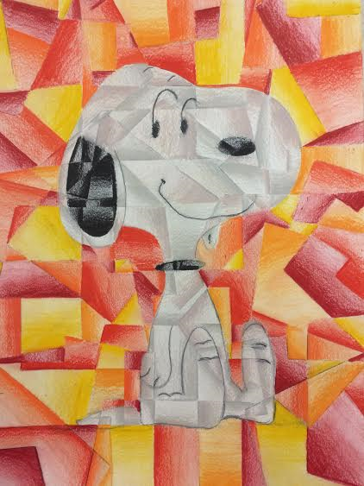

Name:
Class:
CUBISM:

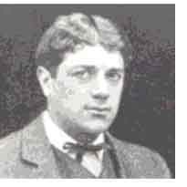
Camouflage Drawing and Sculptural Portrait

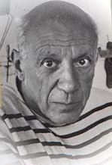
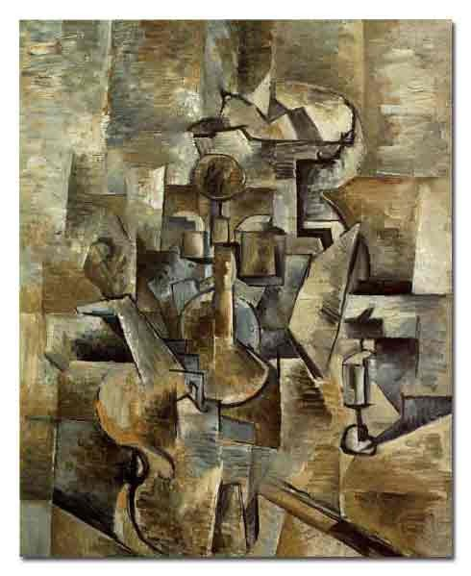
Cubism is often viewed as one of the most influential art movements of the 20th century. Georges Braque and Pablo Picasso are the two artists credited with starting cubism in 1906. The artists lived in Paris and worked closely with one another until the onset of WWI in 1914. Their work is frequently divided into two categories: analytical and synthetic cubism.
Georges Braque, 1882-1963

Pablo Picasso, 1882-1973

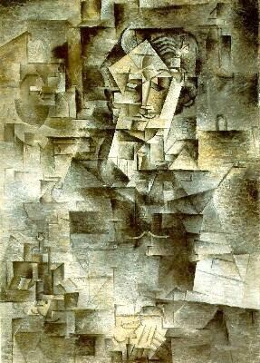
In Analytical Cubism, artists fragment the picture plane so multiple perspectives of the subject matter can be shown at one time. This creates the illusion of movement because we can see several angles of the same subject. The artist achieves this kaleidoscope-like effect by using lines to divide the artwork into geometric shapes. The colors in analytical cubism are usually neutral and muted. Changes in value, or shading, within the many angles help create interest and a sense of density. Subject matter is often ambiguous, or hard to determine.
Braque painted Violin and Candlestick in 1910.

Vocabulary
Contour Line: line that defines and describes the edges of a shape/form
Geometric Shapes: “Man-made shapes; usually have straight lines and corners
Unity: overall quality of wholeness in an artwork
Balance: equally distributed details in an artwork (can be symmetrical or asymmetrical)
Value: degree of lightness or darkness of a color
Contrast: degree of difference
Freestanding Sculpture: 3-D artwork that can be viewed from all angles or sides
Picasso created the Portrait of Kahnweiler, a well-known art dealer in 1910

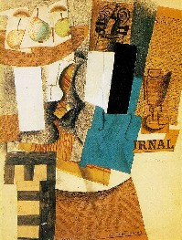
Synthetic Cubism was the second phase of the cubist movement. In synthetic cubism, artists began to collage found elements into their work. Color starts to return to the work of Braque and Picasso. The picture plane continues to be fractured, but not necessarily as much as in analytic cubism. When Braque enlisted in the armed forces during WWI, Picasso continued to develop cubism on his own. Even though the cubist movement came to an end in the 1920’s, elements of cubism can be found in many of the portraits Picasso painted later in his career.

Still Life with Violin and Flute, Picasso, 1912
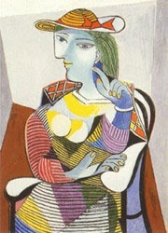
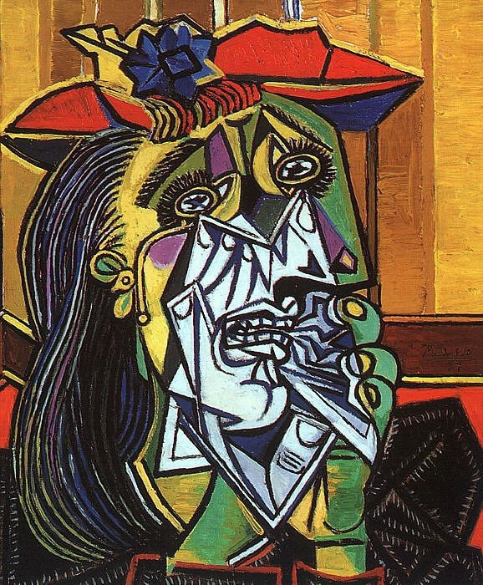

Picasso created the Portrait of Marie-Therese in 1937
Weeping Woman, by Picasso, was painted in 1937

Project #1:
Cubist Camouflage Drawing

The first cubist inspired project is a drawing that reflects the characteristics of analytical cubism.
- You will begin by creating a contour line drawing of an object. It will be important to fill the page and keep your drawing simple.

Color Schemes
Analogous: 3-4 colors that are neighbors on the wheel
Triad: 3 colors that are equally spaced on the wheel
Warm: reds, oranges, and yellows
Cool: blue, green, and violet colors
Complimentary: colors opposite one another on the wheel
Neutral: mixing complementary colors lowers their intensity (grays
and browns)
- Next, you will choose a shape to break up the space with crisscrossed lines and geometric shapes. Be sure to use lines that pass through your contour drawing and go from edge to edge.
- Select a color scheme for your artwork. You may choose your color scheme from the box to the right.

- Using colored pencil, start to color your drawing. Within each geometric shape use blending to create a range of values. Think about how you will create contrast in the areas adjacent to each shape. (Should blending be worked in opposite directions? Will you choose
different colors?)

Project #2:
Sculptural Portrait

The second cubist inspired project is a sculpture that resembles portraits created by Picasso in the years that followed his work with Georges Braque. You will manipulate a 3-D surface to create a portrait that reveals several views, or perspectives, of the face. The finished result will be distorted and interesting!
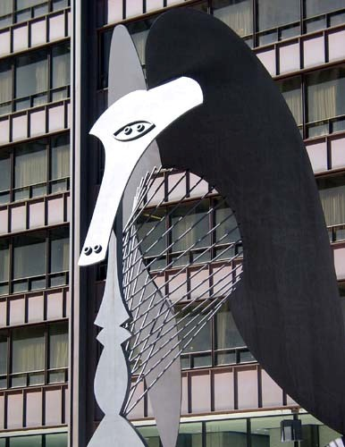
- Secure a wire hanger into a wood base. Carefully bend the wire into an interesting shape. Your sculpture will be freestanding so be sure to examine it from all sides!

- Next, carefully stretch a knee-hi stocking over the wire, all of the way down to the base. You want to avoid getting “runs” in the stocking, so watch for fingernails and jewelry that might snag your artwork!! When you have finished, check your sculpture again and make any desired form changes.

- Apply several layers of diluted glue onto your sculpture. This will help strengthen the artwork as well as provide a base for the paint. Be sure to cover the entire sculpture, including the base!
This sculpture, designed by Picasso, is in Chicago.

- While you are waiting for the glue to dry, make several contour drawings of your sculpture. Begin to plan where you will place the facial features. Think about how your artwork will resemble Picasso’s portraits!

- Using your preliminary sketches as a guide, paint your 3-D portrait!

